******FPT ACADEMY INTERNATIONAL**

**FPT – APTECH COMPUTER EDUCATION**

June – 2024

Centrer Name: ACE-HCMC-2-FPT.

Address: 590 Cach Mang Thang 8, District 3, Ho Chi Minh City, Viet Nam.

Tech Forums

*Project Report Semester 4*

| **Supervisor:** | Mr. Hoàng Đức Quang | |
| --- | --- | --- |
| **Term:** | 04 | |
| **Batch No:** | T1.2206.M1 | |
| **Group No:** | 02 | |
| **No:** | **Full name** | **Roll No.** |
| 1. | Dương Thị Kim Hằng | Student1394620 |
| 2. | Nguyễn Quốc Huy | Student1387904 |
| 3. | Thạch Nguyễn Long Vĩnh | Student1394604 |
| 4. | Nguyễn Trọng Toàn | Student1387829 |

# Table of Content

**Table of Content 3**

**Acknowledgements 5**

Heading 2 5

Introduction 6

Purpose 6

Scope 7

**System Requirement 8**

Functional Requirements 8

System Requirement Specification 11

**eProject Design 13**

1. Architecture and Design of the Project 13

2. Use Case Diagram 14

2.1. User - Use Case Diagram 14

2.2. Moderator - Use Case Diagram 20

2.3. Admin - Use Case Diagram 23

3. Sequence Diagram 24

3.1. User 24

3.2. Moderator 29

3.3. Admin 29

4. Data Flow Diagram (DFD) 31

4.1. Description 31

4.2. Data flow diagram 32

4.3. Admin - Data flow diagram 33

4.4. Moderator - Data flow diagram 37

4.5. User - Data flow diagram 38

5. Flow Charts 41

5.3. Register process (for users, admin, moderators) 43

5.4. Login process (for users, admin, moderators) 44

5.5. Logout process (for users, admin, moderators) 45

5.6. Update the profile's information process (for users, admin, moderators) 46

5.7. Change password process (for users, admin, moderators) 47

5.8. Create Discussion/Blog/Feedback in forum process (for users, admin) 48

6. Entity Relationship Diagram - ERD 50

7. Class Diagram 61

8. Database Structure 63

8.1. User Entity 63

8.2. Person Entity 64

8.3. Roles Entity 66

8.4. RefreshToken Entity 66

8.5. User_stats Entity 68

8.6. Forum Group Entity 69

8.7. Forum Entity 70

8.8. Forum stats Entity 71

8.9. Discussions Entity 71

8.10. Discussion Stats Entity 72

8.11. Comment-info Entity 73

8.12. Comment entity 74

8.13. Comment-votes entity 75

8.14. Votes entity 76

8.15. Tags entity 77

8.16. File-Info entity 79

8.17. Badges entity 80

8.18. Follow-User entity 82

8.19. Bookmark entity 83

**TASK SHEET REVIEW 2 84**

**GUI Interface Design 86**

**● H1 (2/12) 87**

● H2 (1.5/11) 87

# Acknowledgements

As we understand that the e-project is a step-by-step learning environment that closely simulates the classroom and lab-based learning environment into actual implementation. It is a project implementation at your fingertips!! An electronic, live juncture on the machine that allows you to:

✓ Practice step by step i.e., laddered approach.

✓ Build a larger, more robust application.

✓ Usage of certain utilities in applications designed by the user.

✓ Single program to unified code leading to a complete application.

✓ Learn the implementation of concepts in a phased manner.

✓ Enhance skills and add value.

✓ Work on real-life projects.

✓ Give a real-life scenario and help to create applications that are more complicated and useful.

✓ Mentoring through email support.

We would like to send a great thank you to Mr. Hoang Duc Quang and other students for their adorable support during the time of the project.

Besides several mistakes we made in the project, we hope to have more opportunities to widen our knowledge in the developing web world.

## Introduction

In today's rapidly evolving technology landscape, staying abreast of the latest advances, trends, and innovations is paramount for individuals and organizations alike. Enter the dynamic world of Tech Forums - vibrant gatherings where visionaries, professionals, and enthusiasts come together to explore the frontiers of technology, exchange ideas, and catalyze innovation. From bustling conferences packed with industry giants to virtual symposia accessible from anywhere in the world, Tech Forums serve as central platforms for shaping the future of technology and society.

In this comprehensive guide, we delve into the multifaceted world of Tech Forums to uncover their essence, significance, and impact. We navigate through the diverse range of forums, from specialized gatherings focused on niche sectors to sprawling conventions spanning the technological spectrum. We also highlight the key features, benefits, and challenges of these forums, and explore their role in fostering collaboration, driving progress, and providing inspiration. Through this exploration, we unravel the rich tapestry of tech forums and illuminate their central role in navigating the ever-changing landscape of innovation.

## Purpose

Technology Forums are specialized gatherings or events where professionals, experts, enthusiasts, and stakeholders convene to discuss, explore, and advance various aspects of technology. The primary purpose of these forums is to facilitate knowledge exchange, collaboration, and innovation within the technology sector. They provide a platform for participants to showcase new developments, share insights, address challenges, and explore opportunities across different domains of technology.

The evolution of technology forums can be traced back to the early days of technological innovation when inventors, scientists, and engineers would gather in informal settings to exchange ideas and discuss their latest discoveries. Over time, as technology became more pervasive and complex, the need for structured forums arose. In the latter half of the 20th century, with the rapid advancement of computing, telecommunications, and other emerging technologies, formalized technology conferences and symposiums began to emerge. These early forums laid the foundation for the diverse array of technology-focused events that exist today, ranging from industry-specific conferences to global summits.

Technology forums encompass a wide range of formats and scopes, catering to various interests, specialties, and geographic regions. Some common types of technology forums include:

* Industry-Specific Forums: These forums focus on specific sectors or industries within the technology domain, such as cybersecurity, biotechnology, artificial intelligence, or renewable energy. They provide a platform for professionals and stakeholders within a particular industry to discuss trends, challenges, and innovations relevant to their field.
* Global Forums: Global technology forums attract participants from around the world and address broad themes and trends shaping the global technology landscape. These forums often feature keynote speakers, panel discussions, and workshops covering a wide range of topics, reflecting the diverse interests and perspectives of a global audience.
* Virtual Forums: With the advent of digital communication technologies, virtual technology forums have become increasingly popular. These forums are hosted online, allowing participants to attend remotely from anywhere in the world. Virtual technology forums offer greater accessibility and flexibility, eliminating the barriers of travel and accommodation while still providing opportunities for networking, learning, and collaboration.

Regardless of their format or focus, technology forums play a crucial role in fostering collaboration, driving innovation, and shaping the future of technology. They serve as catalysts for progress, empowering individuals and organizations to stay ahead in an ever-changing technological landscape.

# 

## 

## Scope

The forum chat software will include the following key features and functionalities:

* User management: Registration, authentication, and authorization.
* Discussion management: Creation, organization, and moderation of discussion threads.
* Messaging: Posting messages and replies within discussion threads.
* Notification system: Real-time updates for new messages, replies, and mentions.
* Search functionality: Ability to search for discussions and messages.
* User profiles: Customizable profiles with relevant information.

# System Requirement

We will be designing a system with the following requirements:

1. Any non-member (guest) can search and view questions. However, to add or upvote a question, they have to become a member.
2. Non-member (guest) can register to access useful features on the platform.
3. Members should be able to post new questions.
4. Members should be able to add an answer to an open question.
5. Members can add comments to any question or answer.
6. A member can upvote a question, answer or comment.
7. Members can flag a question, answer or comment, for serious problems or moderator attention.
8. Any member can add a [bounty](https://stackoverflow.com/help/bounty) to their question to draw attention.
9. Members will earn [badges](https://stackoverflow.com/help/badges) and reputations for being helpful.
10. Members can vote to [close](https://stackoverflow.com/help/closed-questions) a question; Moderators can close or reopen any question.
11. Members can add [tags](https://stackoverflow.com/help/tagging) to their questions. A tag is a word or phrase that describes the topic of the question.
12. Members can vote to [delete](https://stackoverflow.com/help/deleted-questions) extremely off-topic or very low-quality questions.
13. Moderators can close a question or undelete an already deleted question.
14. The system should also be able to identify most frequently used tags in the questions.
15. The system should have a reputation burning mechanism.

## Functional Requirements

1. User Registration and Authentication:
   * Users should be able to register for an account on the platform.
   * Users should be able to register for an account on the platform with social media.
   * Different user roles (e.g., administrator, moderator, regular user) with varying permissions are implemented.
   * Users should be able to log in securely using their credentials.
   * The platform should support password recovery mechanisms.
2. Posting Questions and Answers:
   * Users should be able to post questions on various topics.
   * Users should be able to provide detailed descriptions and context for their questions.
   * Users should be able to post answers to questions, including text, images.
   * Users can post a limited number of questions per day.
3. Voting and Reputation System:
   * Users should be able to upvote or downvote both questions and answers.
   * The platform should have a reputation system where users gain reputation points for their contributions, such as posting helpful answers or questions, and lose points for violations like spamming or abusive behavior.
   * Reputation should influence privileges, such as the ability to access certain features.
4. Reputation Burning System:
   * Users must spend reputation to overcome restrictions (eg number of daily questions...).
   * Users must spend a certain amount of additional reputation based on their current reputation if they use the bounty on their question.
5. The Great Ranking:
   * The platform should have a Ranking System where users can track their position in local or global forums.
6. Tagging and Categorization:
   * Users should be able to tag their questions with relevant keywords to help categorize and organize content.
   * The platform should provide a structured way to browse questions by category or tag.
7. Search Functionality:
   * Users should be able to search for questions and answers based on keywords, tags, or categories.
   * The search functionality should provide relevant and accurate results, possibly including sorting options.
8. Notification System:
   * Users should receive notifications for activities relevant to them, such as answers to their questions, comments on their posts, or changes in their reputation.
   * Users should have the option to customize their notification preferences.
9. User Profile Management:
   * Users should be able to edit their profiles, including adding a bio, profile picture, and other relevant information.
   * Users should be able to view their activity history, including questions asked, answers given, and comments made.
10. Moderation Tools:
    * The platform should provide moderation tools for users with sufficient reputation, including the ability to flag posts for review, edit content for clarity or correctness, and close or reopen questions.
    * Administrators should have access to additional moderation features to manage user accounts, handle disputes, and enforce community guidelines.
11. Integration with Third-party Services:
    * The platform may support integration with third-party services for features such as single sign-on, social sharing.
12. Internationalization:
    * It should support multiple languages and provide mechanisms for translating content and user interfaces.
13. Admin

| **Item** | **Functional requirement** |
| --- | --- |
| 2. Admin can manage forum | * Admin can create new forums. * Admin can view all forums. * Admin can edit any editors. * Admin can delete any forums. |
| 3. Admin can manage tags | * Admin can add new tags. * Admin can edit all tags. * Admin can delete any tags. * Admin can review all the tags. |
| 4. Admin can manage discussions | * Admin can view the author's pending and posted posts. * Admin can edit (add/remove) topic hashtags in discussions. * Admin can edit (show/hide) the comment in discussion. * Admin can read comments and remove comments that are offensive. * Admin can mark as important for discussions. * Admin can move discussion to new forum. |
| 5. Admin can manage badges | * Admin can track user activities through their post and interaction metrics. * Admin can create assessment standards to measure active users. * Admin can assign user tiers according to forum standards. |
| 6. Admin can manage email configuration. | * Admin can send the email to users through the provided email. * Admins can change the current admin email as long as they need to. |

## System Requirement Specification

* TechForum application which makes use of technologies such as Java, Spring boot, JPA, ReactJs, Flutter,...
* Database: MySQL 8.x database will be used for data storage.

**TASK SHEET REVIEW 1**

| Project Ref. No.: | | Project Title: | Activity Plan Prepared By: | Date of Preparation of Activity Plan: | | | |
| --- | --- | --- | --- | --- | --- | --- | --- |
| No. | Task | Actual Start Date | Actual Days | Team Mate Names | Status |
| 1 | Problem Statement | TechForum | Vĩnh | 15/05/2024 | 01 | Hằng |  |
| 2 | Requirement Specification | 15/05/2024 | 01 | Group 2 |  |
| 3 | System Requirement Specification | 15/05/2024 | 01 | Vĩnh |  |

# eProject Design

## Architecture and Design of the Project

*Figure: Displays the application architecture of the project.*

Architecture flow of spring boot Applications Spring boot uses all the features of Spring like Spring MVC, Spring Data and JPA. A generic Spring Boot application consists of a controller which serves the clients HTTP request. This controller then interacts with the service layer which processes the request to modify the model and the database using the JPA repository through dependency injection.

## Use Case Diagram

### User - Use Case Diagram

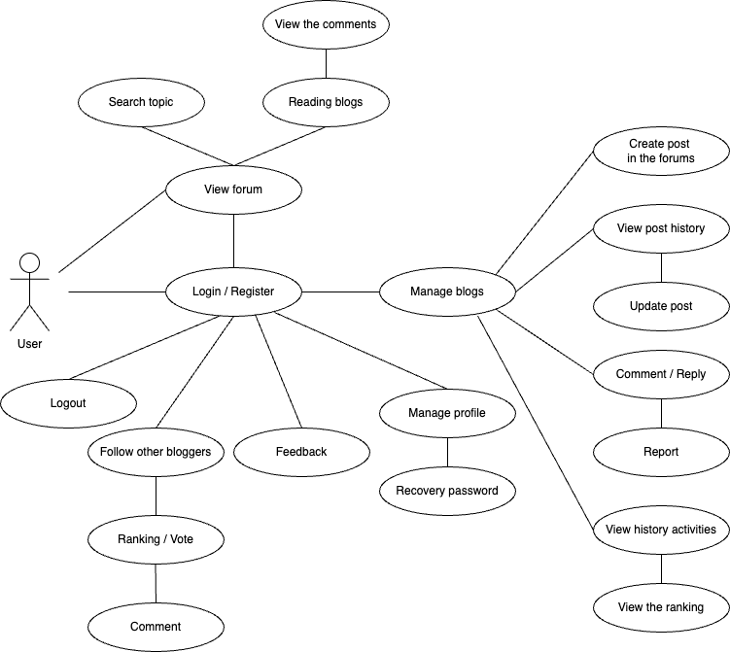

* + 1. ***User can view forum and searching topic***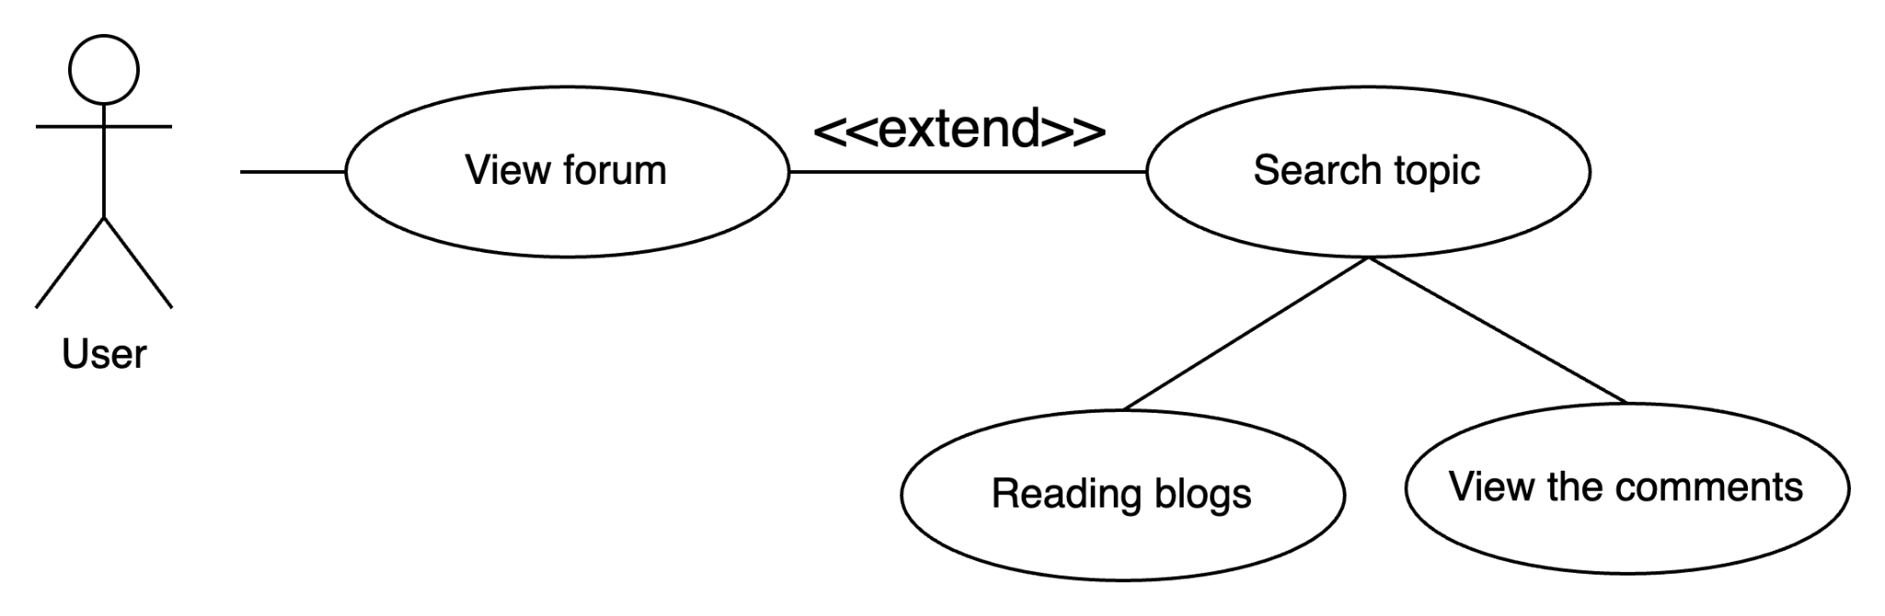

| **Author** |  | |
| --- | --- | --- |
| **Use Case** | User can view forum and searching topic | |
| **Actors** | User |  |
| **Description** | Every user, including those who haven't registered, has access to view and search data as reading (blogs, discussions, comments, etc.). | |
| **Requirements** | Users who want to view forum information need to search by topic for the discussions's name, tags, comments, etc. | |
| **Status** | Show information page | |
| **Basic flow** | Actor action: | System Response: |
|  | 1. Users can access TechForums to view any information such as posts, discussions, etc. | 2. The system will go to the respective forum. |
|  | 3. Users can search for the topic by entering keywords in the search bar or clicking directly on tags in forums. | 4. The system will redirect to the forum-group including blogs, comments, etc. |
| **Alternative flow** |  |  |
| **Exception** |  |  |

* + 1. ***User can register/login account***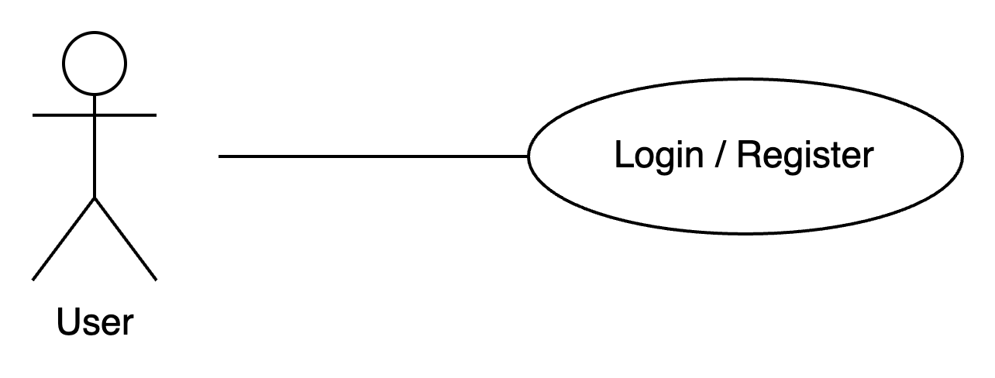

| **Author** |  | |
| --- | --- | --- |
| **Use Case** | User can register a new account or login | |
| **Actors** | User |  |
| **Description** | Users must log in to the forum to be able to do actions such as creating posts, leaving comments, and engaging in forum-group discussion. You may sign up a new account by a variety of methods if you don't already have one (ex: email, google or facebook). | |
| **Requirements** | To engage in forum activities, users need to register. The user must provide information for registration. If you have a current Facebook or Google account, you could login via both of them. | |
| **Status** | Show information page | |
| **Basic flow** | Actor action: | System Response: |
|  | 1. Users click the Register Button to register a new account. If users have a current Facebook or Google account, they could login via both. | 2. The system will redirect to the forum page. At the same time, an announcement will pop up to users about “Login Successfully.” |
| **Alternative flow** |  |  |
| **Exception** |  |  |

* + 1. ***User can manage their profile and recovery password***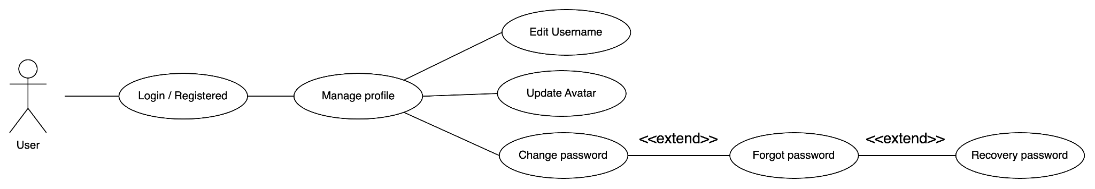

| **Author** |  | |
| --- | --- | --- |
| **Use Case** | Users can manage their profile (username, avatar, change/recovery password, etc.) | |
| **Actors** | User |  |
| **Description** | Users can edit their personal page, including elements like name, avatar, password changes, and other details, once they have successfully joined. You may also reset your password here if you forget it. | |
| **Requirements** | Only registered users could edit the profile or recover the password. | |
| **Status** | Show information page | |
| **Basic flow** | Actor action: | System Response: |
|  | 1. When a users clicks on the “Edit information” button, a form will be displayed to enter information with the following fields:   * Avatar * Username * Password / Recovery * Blog History | 2. The system will check and validate the user's details, If it is correct it will save it into the database. At the same time, an announcement will pop up to users about “Your details updated successfully.” |
| **Alternative flow** |  |  |
| **Exception** |  |  |

* + 1. ***User can manage their blogs/posts***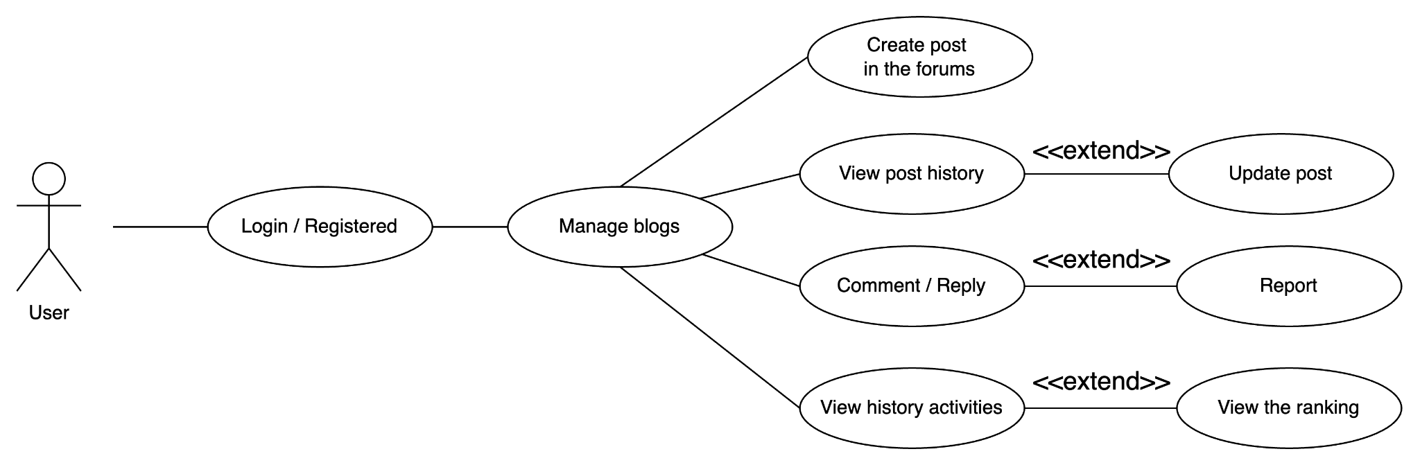

| **Author** |  | |
| --- | --- | --- |
| **Use Case** | Registered users in the forum can engage in activities related to blogs. | |
| **Actors** | User |  |
| **Description** | User can manage their blogs/posts in discussions | |
| **Requirements** | Post management (creation, reading, editing, etc.) is restricted to registered users only. | |
| **Status** | Show information page | |
| **Basic flow** | Actor action: | System Response: |
|  | 1. By selecting “Create new Discussion” from the Forum menu, users may add and modify new posts or discussions. The user will then be prompted to provide details about the post they want to make in a table that appears. Modal Bootstrap is used to construct this table. | 2. The system will check and validate the user's details, If it is correct it will save it into the database. At the same time, an announcement will pop up to users about “Created successfully.” |
| **Alternative flow** |  |  |
| **Exception** |  |  |

* + 1. ***User can logout***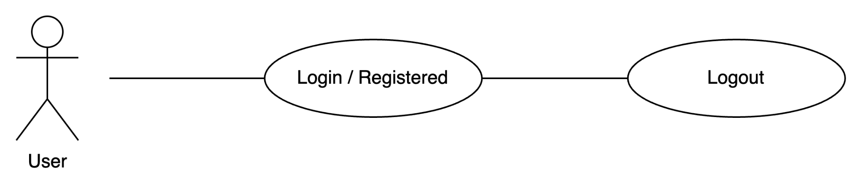

| **Author** |  | |
| --- | --- | --- |
| **Use Case** | Users can log out of the forum | |
| **Actors** | User |  |
| **Description** | Logging out allows users to leave the page if they are not using the forum. | |
| **Requirements** | Only those who are logged in to the forum are able to log out. | |
| **Status** | Show information page | |
| **Basic flow** | Actor action: | System Response: |
|  | 1. Users click the logout button in the lower right corner of the screen to close the forum. | 2. The system will display a logout status message and return to the home page after recording the task. |
| **Alternative flow** |  |  |
| **Exception** |  |  |

* + 1. ***User can follow blogger, ranking and comment in forum***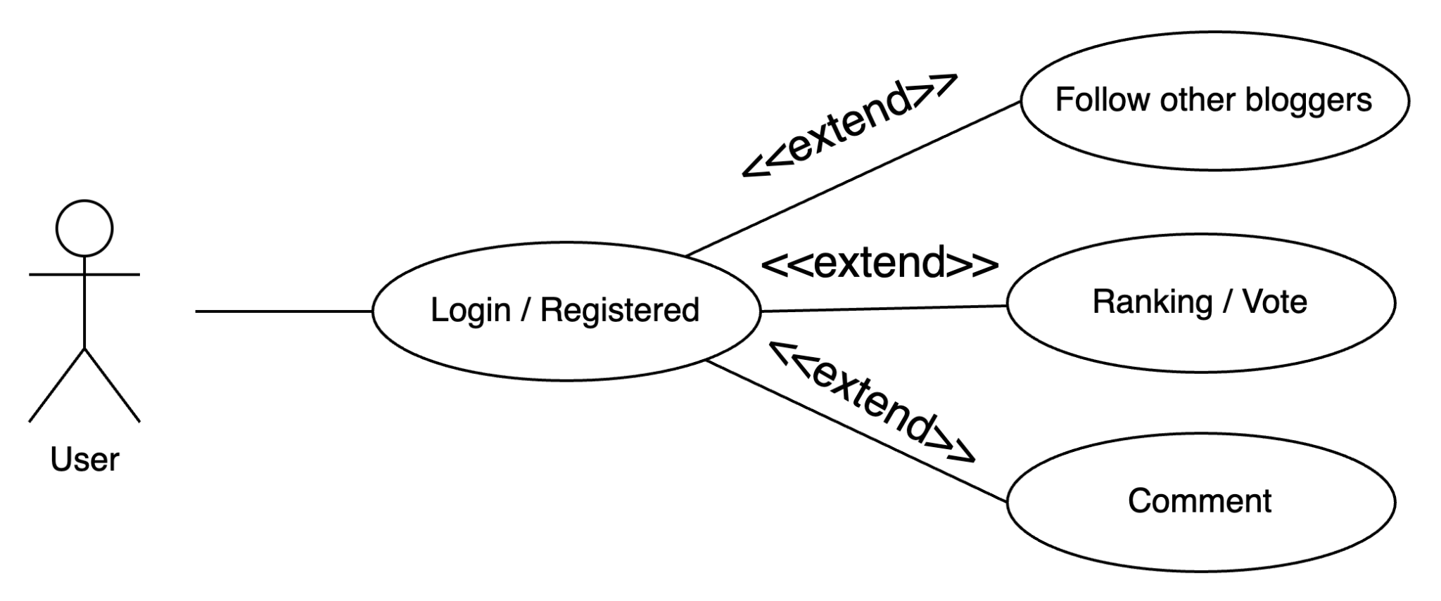

| **Author** |  | |
| --- | --- | --- |
| **Use Case** | Registered users in the forum can engage in other activities. | |
| **Actors** | User |  |
| **Description** | After creating an account, users may engage in a variety of different forum activities, such as following other posters and voting or commenting on their posts. You may provide the forum's administrator or moderator with feedback while it's being used. | |
| **Requirements** | Other activities (follow, ranking, vote, comment, etc.) are restricted to registered users only and users as admin/moderator roles. | |
| **Status** | Show information page | |
| **Basic flow** | Actor action: | System Response: |
|  | 1. You have the option to click on the name of another person and select "Follow." | 1. Upon receipt of the tracking request, the system will navigate straight to the specified user's profile page. |
|  | 1. A user can decide whether or not to like a post or remark made by another user. Users can also choose to react at the same time by clicking the reply button beneath the remark. | 1. If the user enters a remark that deviates from community norms, for example, the system will ask them to re-operate before returning the input results. |
| **Alternative flow** |  |  |
| **Exception** |  |  |

### *Moderator - Use Case Diagram*

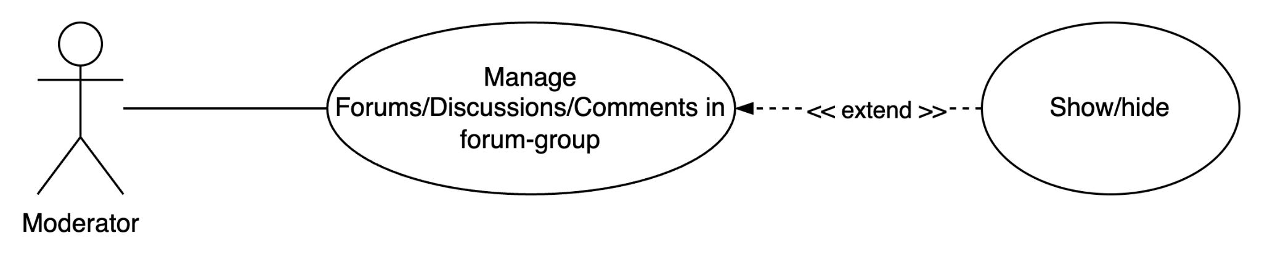

* + 1. ***Moderator can manage forum group, discussions and comment in there***

| **Author** |  | |
| --- | --- | --- |
| **Use Case** | Moderator can manage forum group, discussions and comment in there | |
| **Actors** | Moderator |  |
| **Description** | Moderators have the ability to control offensive content in posts and comments by either seeing or hiding it. | |
| **Requirements** | Manage forum groups are restricted to users as admin/moderator roles. | |
| **Status** | Show information page | |
| **Basic flow** | Actor action: | System Response: |
|  | 1. Moderators may analyze and review content that has been uploaded, and they can choose to hide posts that don't fit the criteria for additional administration approval. | 1. The moderator will review the process. The system will provide the findings after receiving a request. |
| **Alternative flow** |  |  |
| **Exception** |  |  |

* + 1. ***Moderator can manage members in forum-group***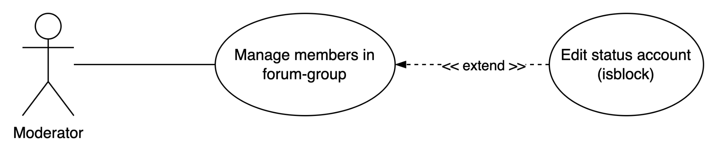

| **Author** |  | |
| --- | --- | --- |
| **Use Case** | Moderator can manage members forum group | |
| **Actors** | Moderator |  |
| **Description** | Managing small groups in huge forums will be the responsibility of the user in the second job, moderator. They will view and discuss with members. They will oversee that group in addition, removing, recalling, and hidden postings that have an impact on the group. | |
| **Requirements** | Manage forum groups are restricted to users as admin/moderator roles. | |
| **Status** | Show information page | |
| **Basic flow** | Actor action: | System Response: |
|  | 1. Participants in small groups and moderators on the assigned user list are able to log in. Members in brief talks can be added or blocked. | 1. The moderator will review the process. The system will provide the findings after receiving a request. |
| **Alternative flow** |  |  |
| **Exception** |  |  |

### 

### Admin - Use *Case* Diagram

| **Author** |  | |
| --- | --- | --- |
| **Use Case** | Admin can manage members, forums, discussions, tags, badges and email configuration. | |
| **Actors** | Admin |  |
| **Description** | The admin has the most power in the forum; they may control how members, moderators, and the forum are run. | |
| **Requirements** | The access that administrators have to use the forum is unrestricted. | |
| **Status** | Show information page | |
| **Basic flow** | Actor action: | System Response: |
|  | 1. The administrator has the ability to add, update, remove, and change permissions for custom users. |  |
|  | 1. Admin can create new forums, view and edit them |  |
|  | 1. Admin have the ability to add, edit, and manage tags in the forum based on the situation at hand. |  |
|  | 1. The admin can moderate forum conversations, post new comments, and remove offensive ones. |  |
|  | 1. Admin have the ability to monitor activity in the forum and adjust and measure it depending on user interactions to set up user levels. |  |
|  | 1. Admins can manage email configuration by sending it to users through the provided email. | 1. The admin will review the process. The system will provide the findings after receiving a request. |
| **Alternative flow** |  |  |
| **Exception** |  |  |

## Sequence Diagram

### *User*

* + 1. View - Unregistered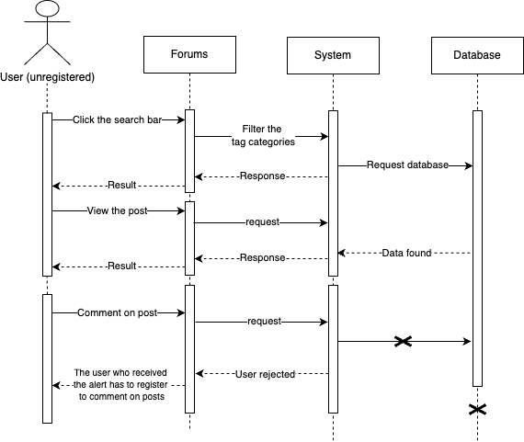
    2. Register/Login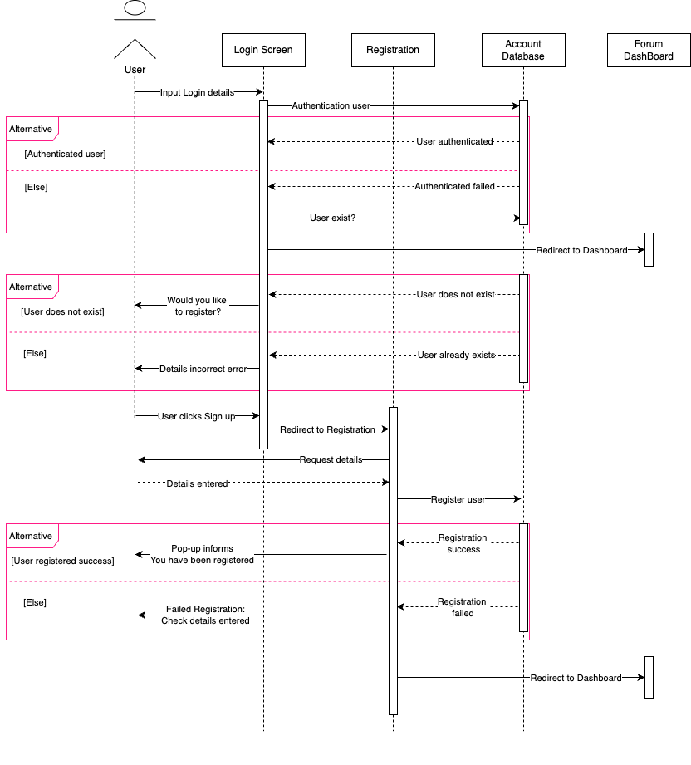
    3. Change Password / Reset Password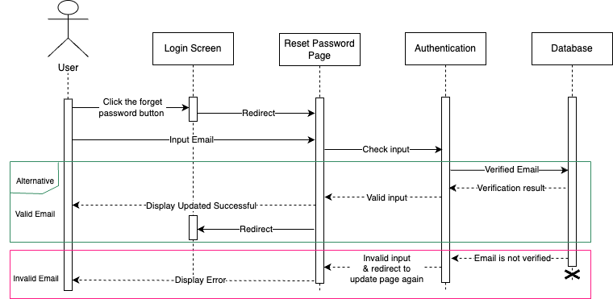
    4. Manage Profile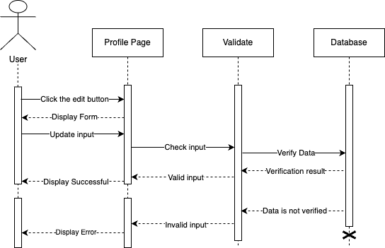
    5. Manage Personal Blogs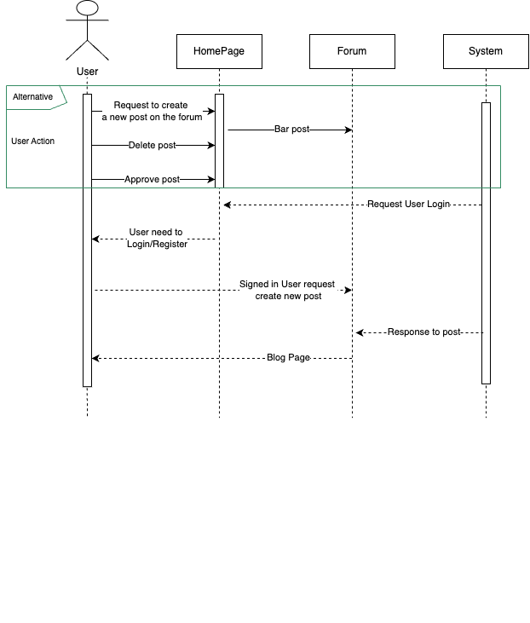
    6. Feedback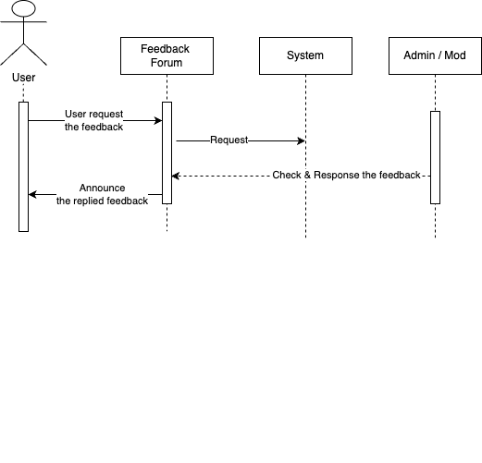

### *Moderator*

### *Admin*

* + 1. Login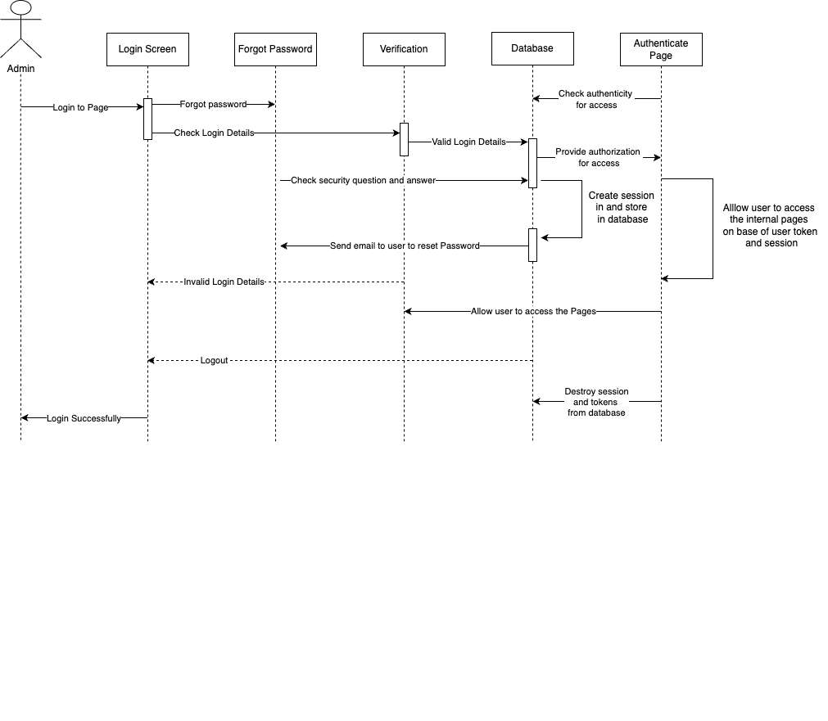
    2. Management all forum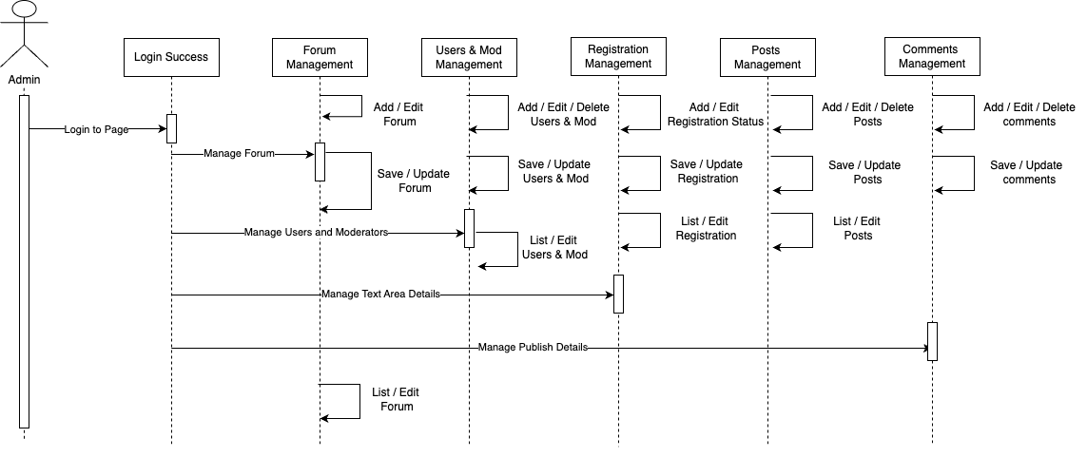

## 

## Data Flow Diagram (DFD)

### Description

Define: Data Flows Diagram (DFD) describes the information flow in the system. The next step of system analysis is to consider in detail the information necessary for the implementation of the functions discussed above and the one necessary for the improvement of the functions. The modeling tool frequently used for this purpose is DFD. DFD will support 4 main activities:

Analysis: DFD is used to determine the requirements of users.

Design: DFD is used to map out plans and illustrate solutions to analysis and users while designing a new system.

Communication: one of the strengths of DFD is its simplicity and ease of understanding to analysts and users;

Document: DFD is used to provide a special description of requirements and system design. DFD provides an overview of key functional components of the system but it does not provide any detail on these components. We have to use other tools like database dictionaries, and process specifications to get an idea of which information will be exchanged and how.

The main components of Context Diagram:

|  | **External** | External factors can be a person, a group of persons or an organization that are sources of information for the systems and are where system products are transferred to. |
| --- | --- | --- |
|  | **The process** | Shows the common function of the system. |
|  | **Data flow** | Describe the movement of information from one part of the system to another. |
|  | **Data store** | The Data Store is used to model a collection of data packets at rest. A store is represented graphically by two parallel lines. The name of a Data Store that identifies the store is the plural of the name of the packets that are carried by flows into and out of the Data Store. |

### Data flow diagram

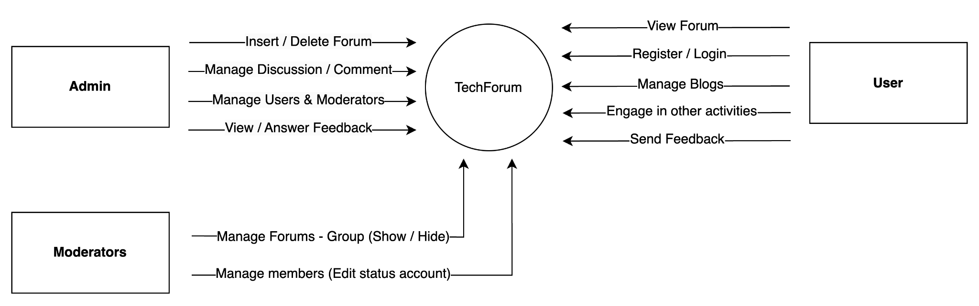

### Admin - Data flow diagram

* + 1. **Admin - Data flow diagram level 1s**

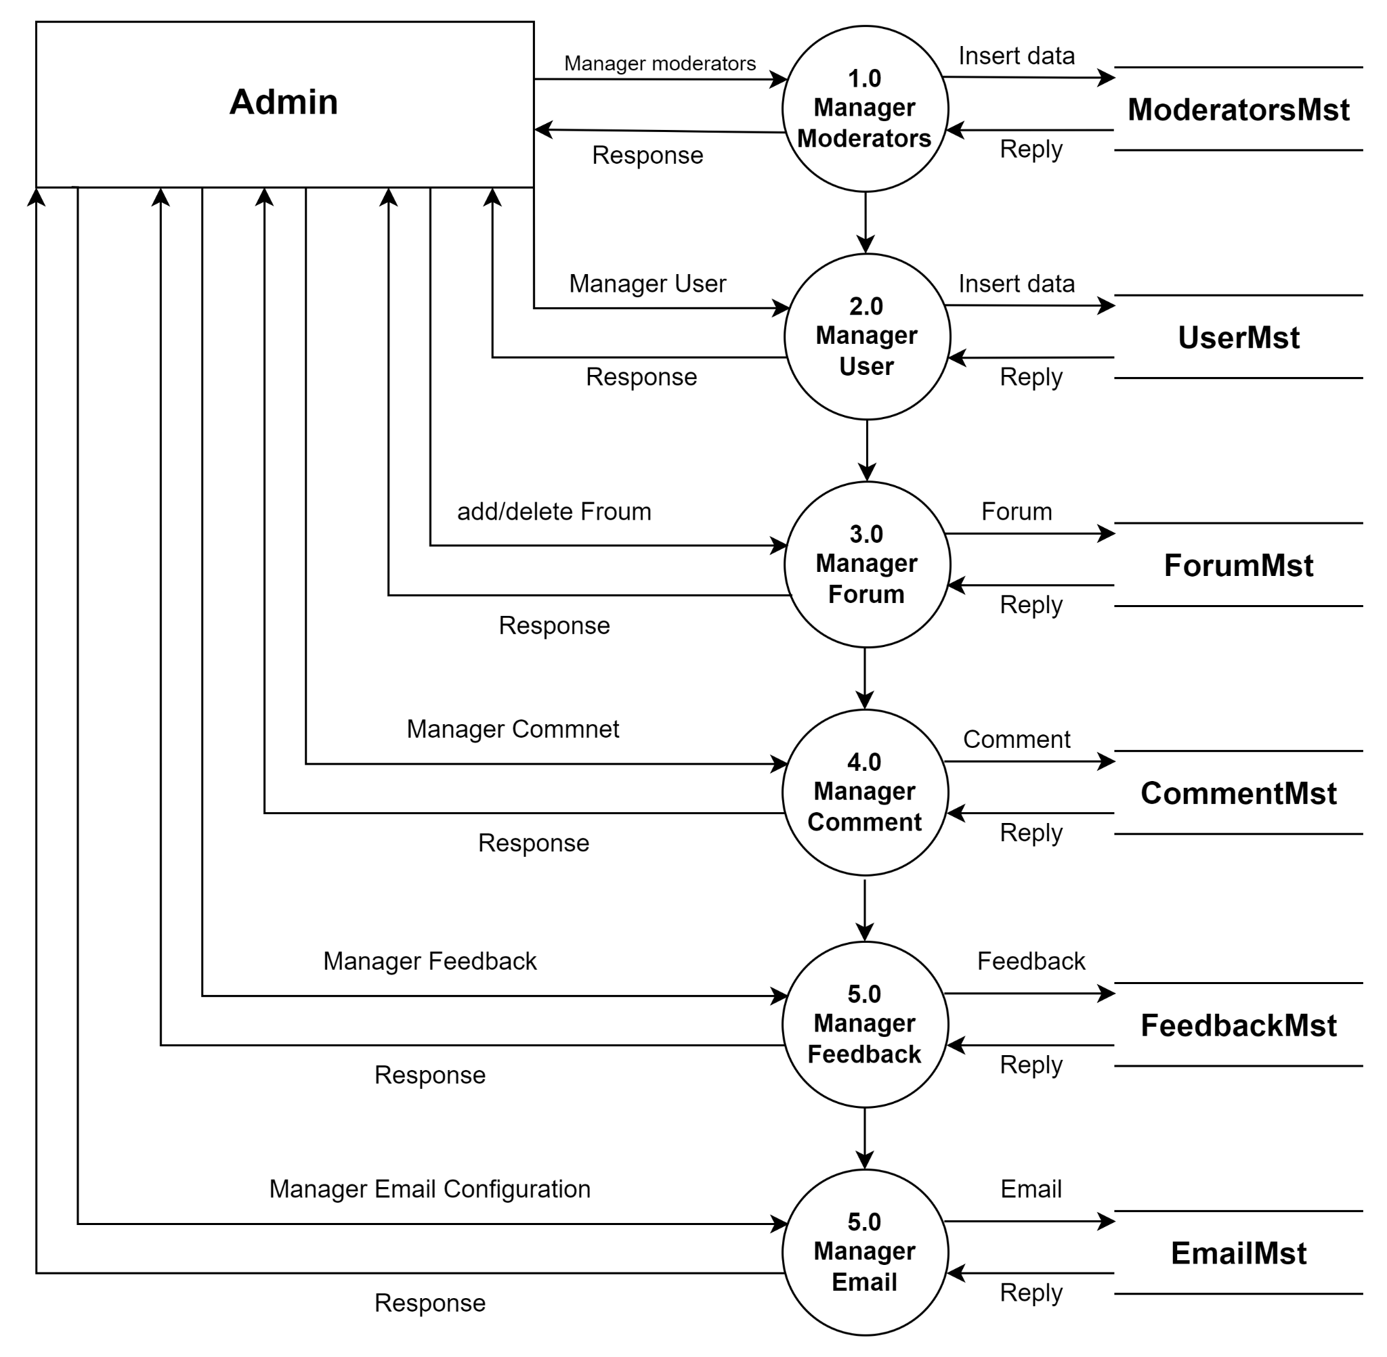

* + 1. **Admin - Data flow diagram level 2nd**
       1. **Admin manage moderator**

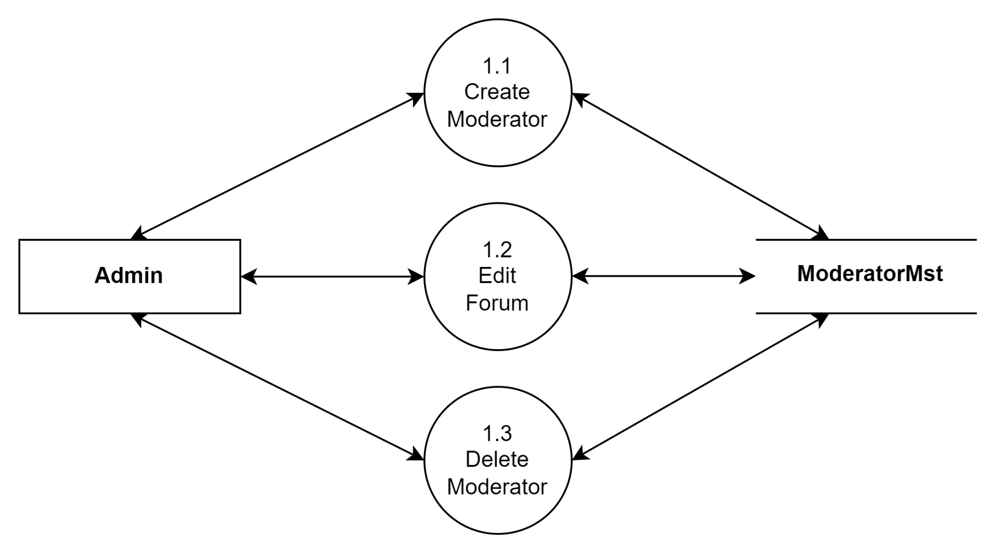

* + - 1. **Admin Manage User**

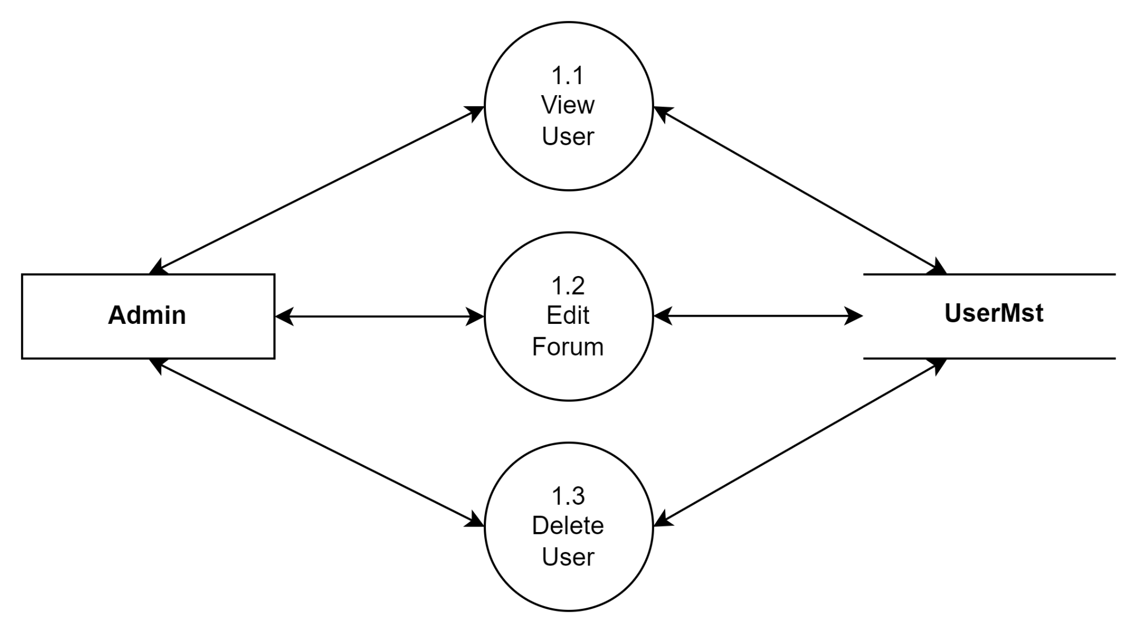

* + - 1. **Admin Manage Forum**

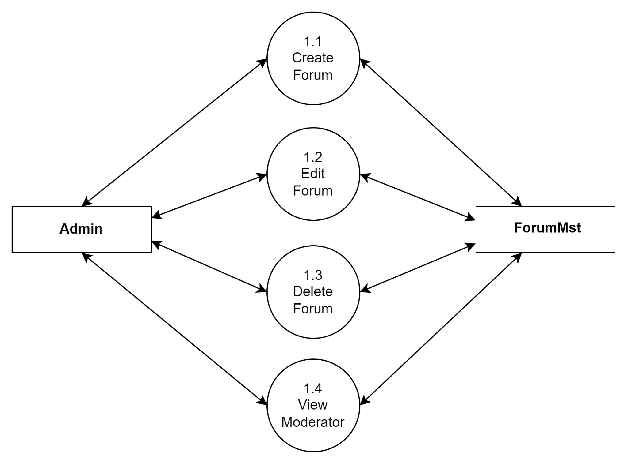

* + - 1. **Admin Manage Comment**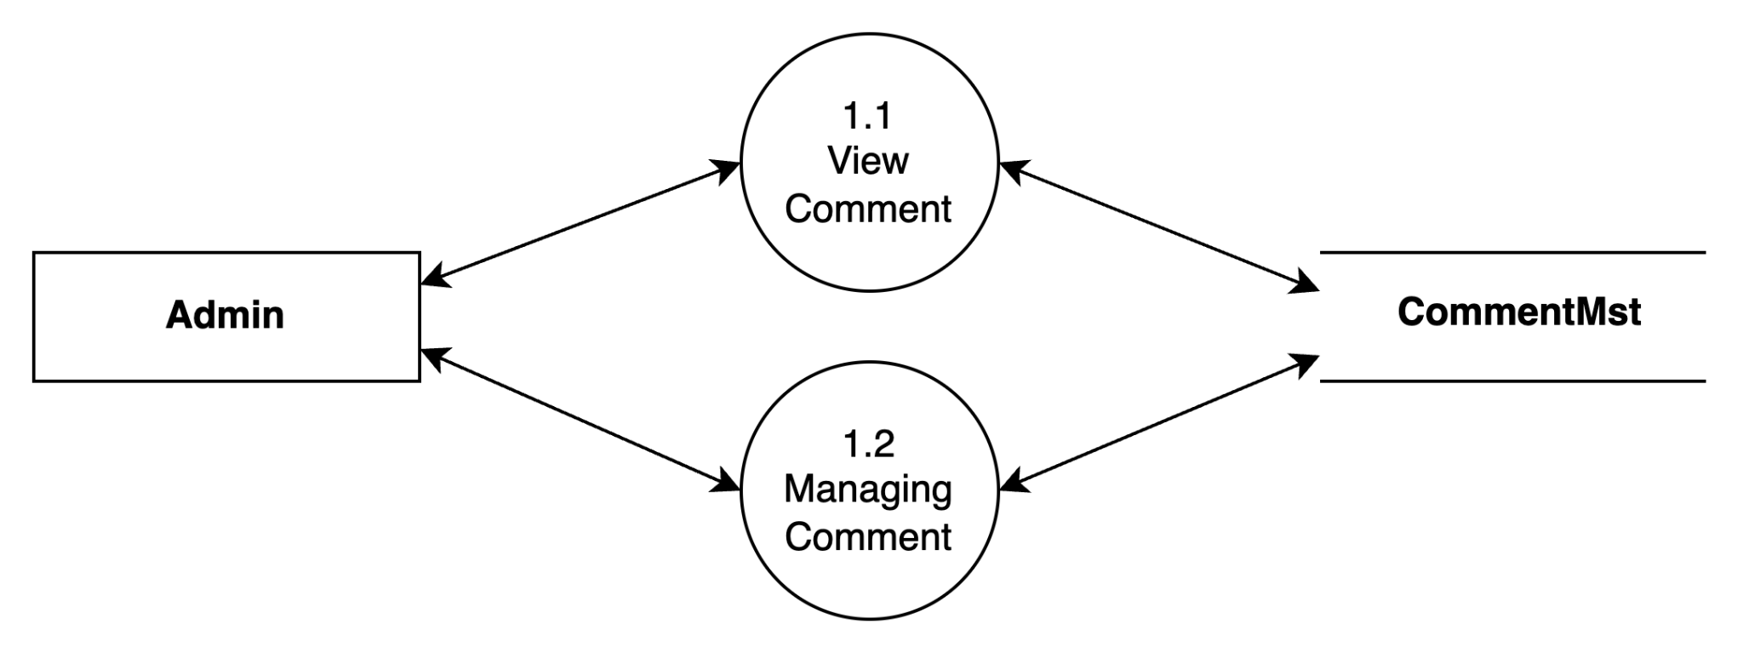
      2. **Admin Manage Feedback**

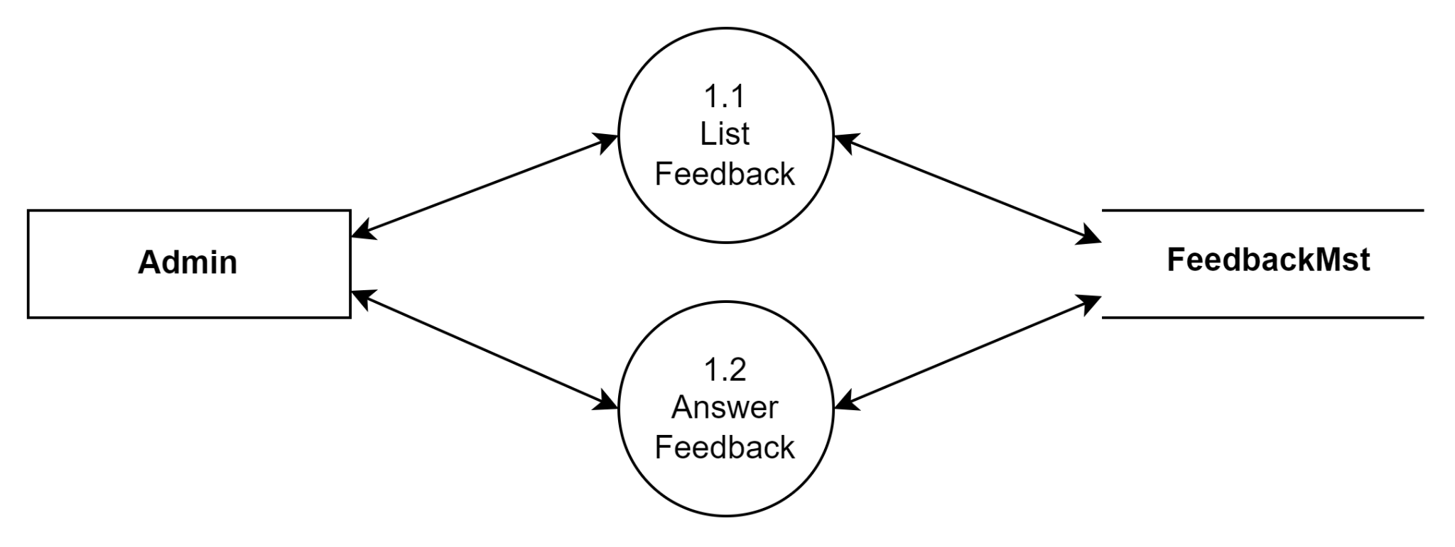

* + - 1. **Admin Manage Email**

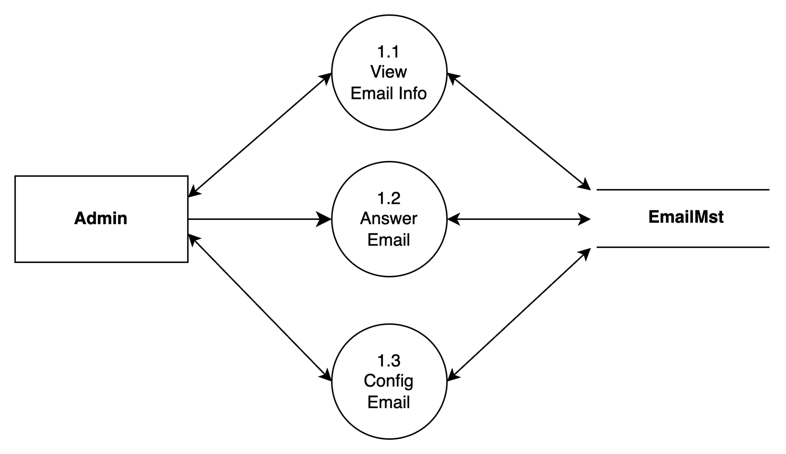

### *Moderator - Data flow diagram*

* + 1. **Moderator - Data flow diagram level 1st**

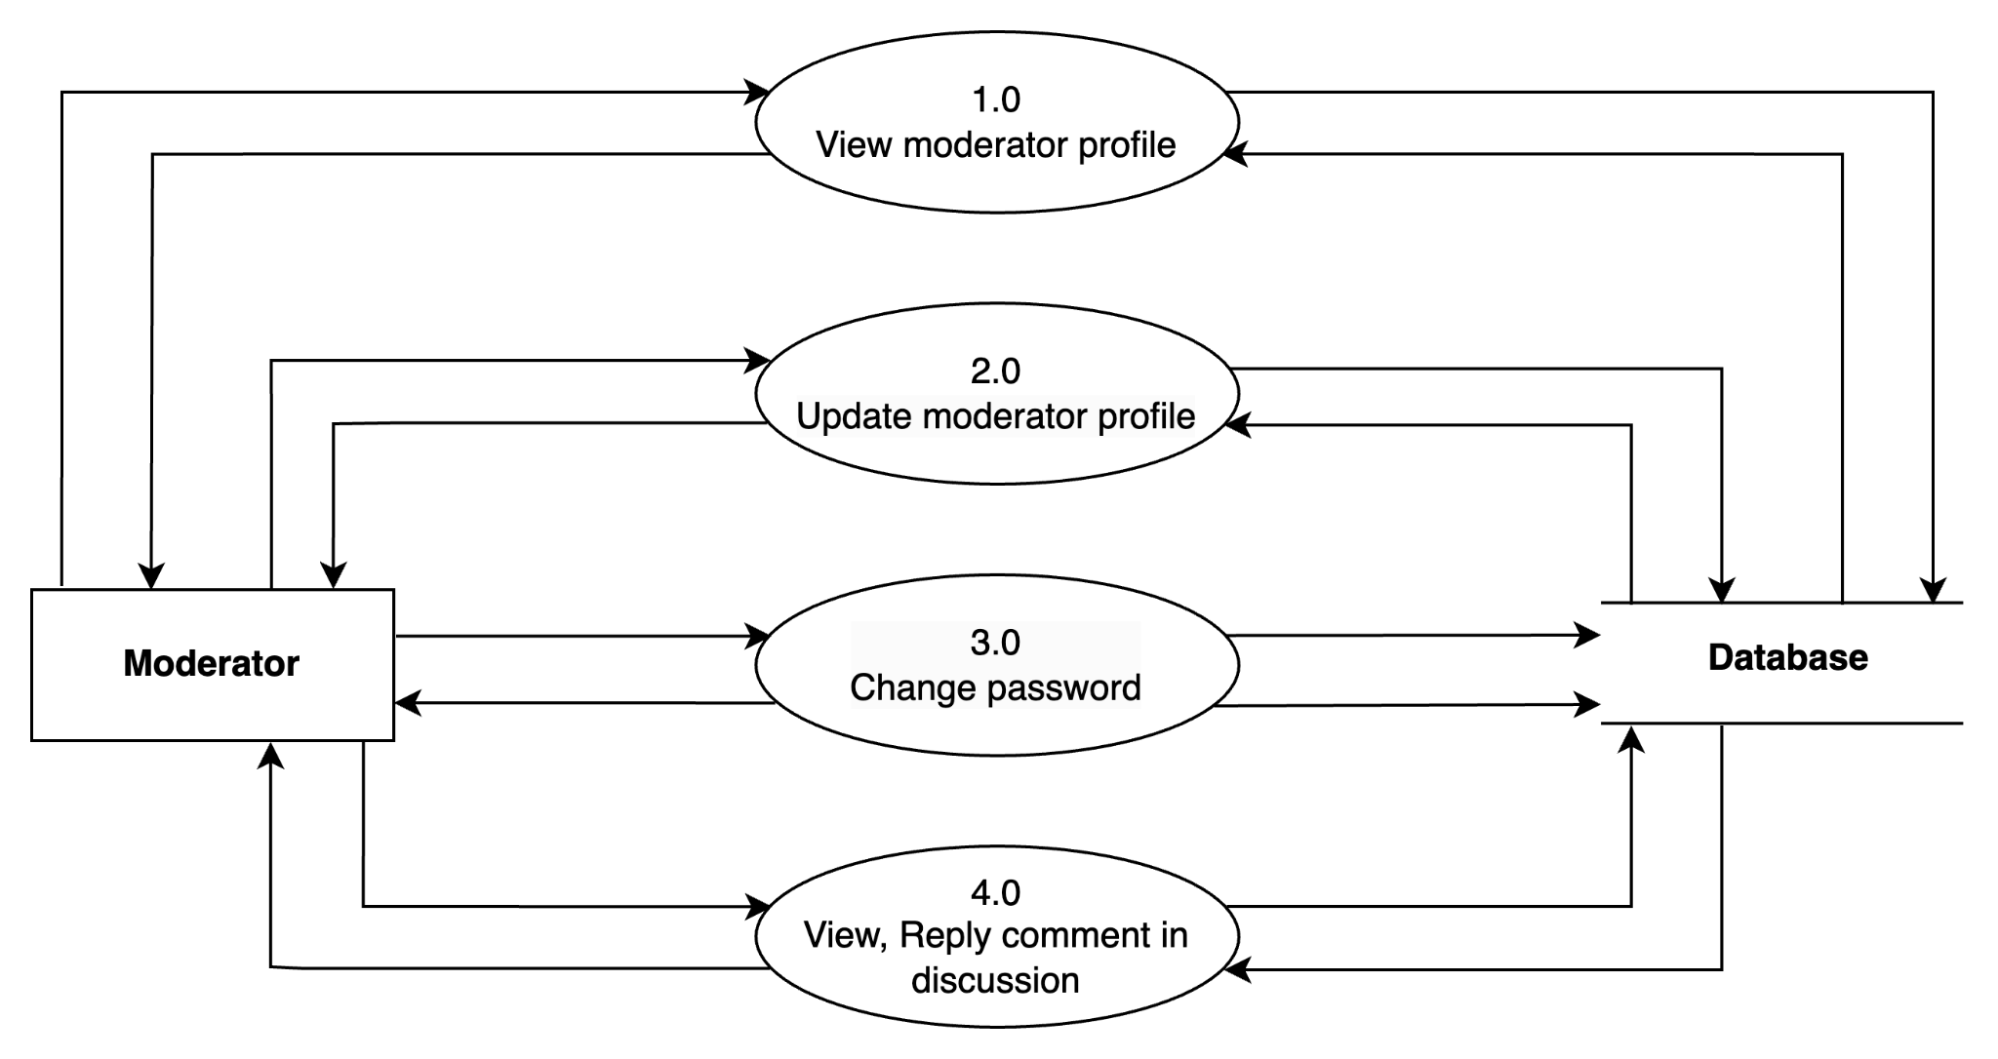

### *User - Data flow diagram*

* + 1. **User - Data flow diagram level 1st**

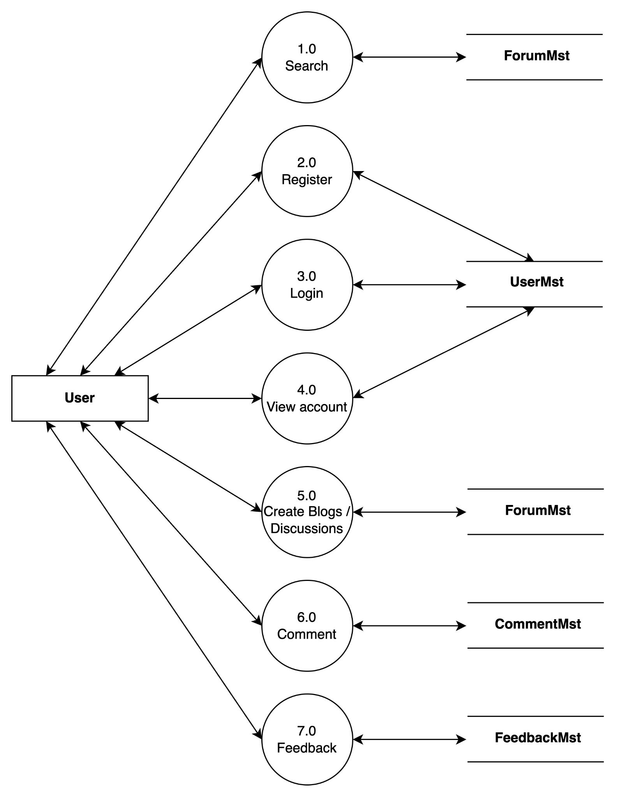

* + 1. **User - Data flow diagram level 2nd**

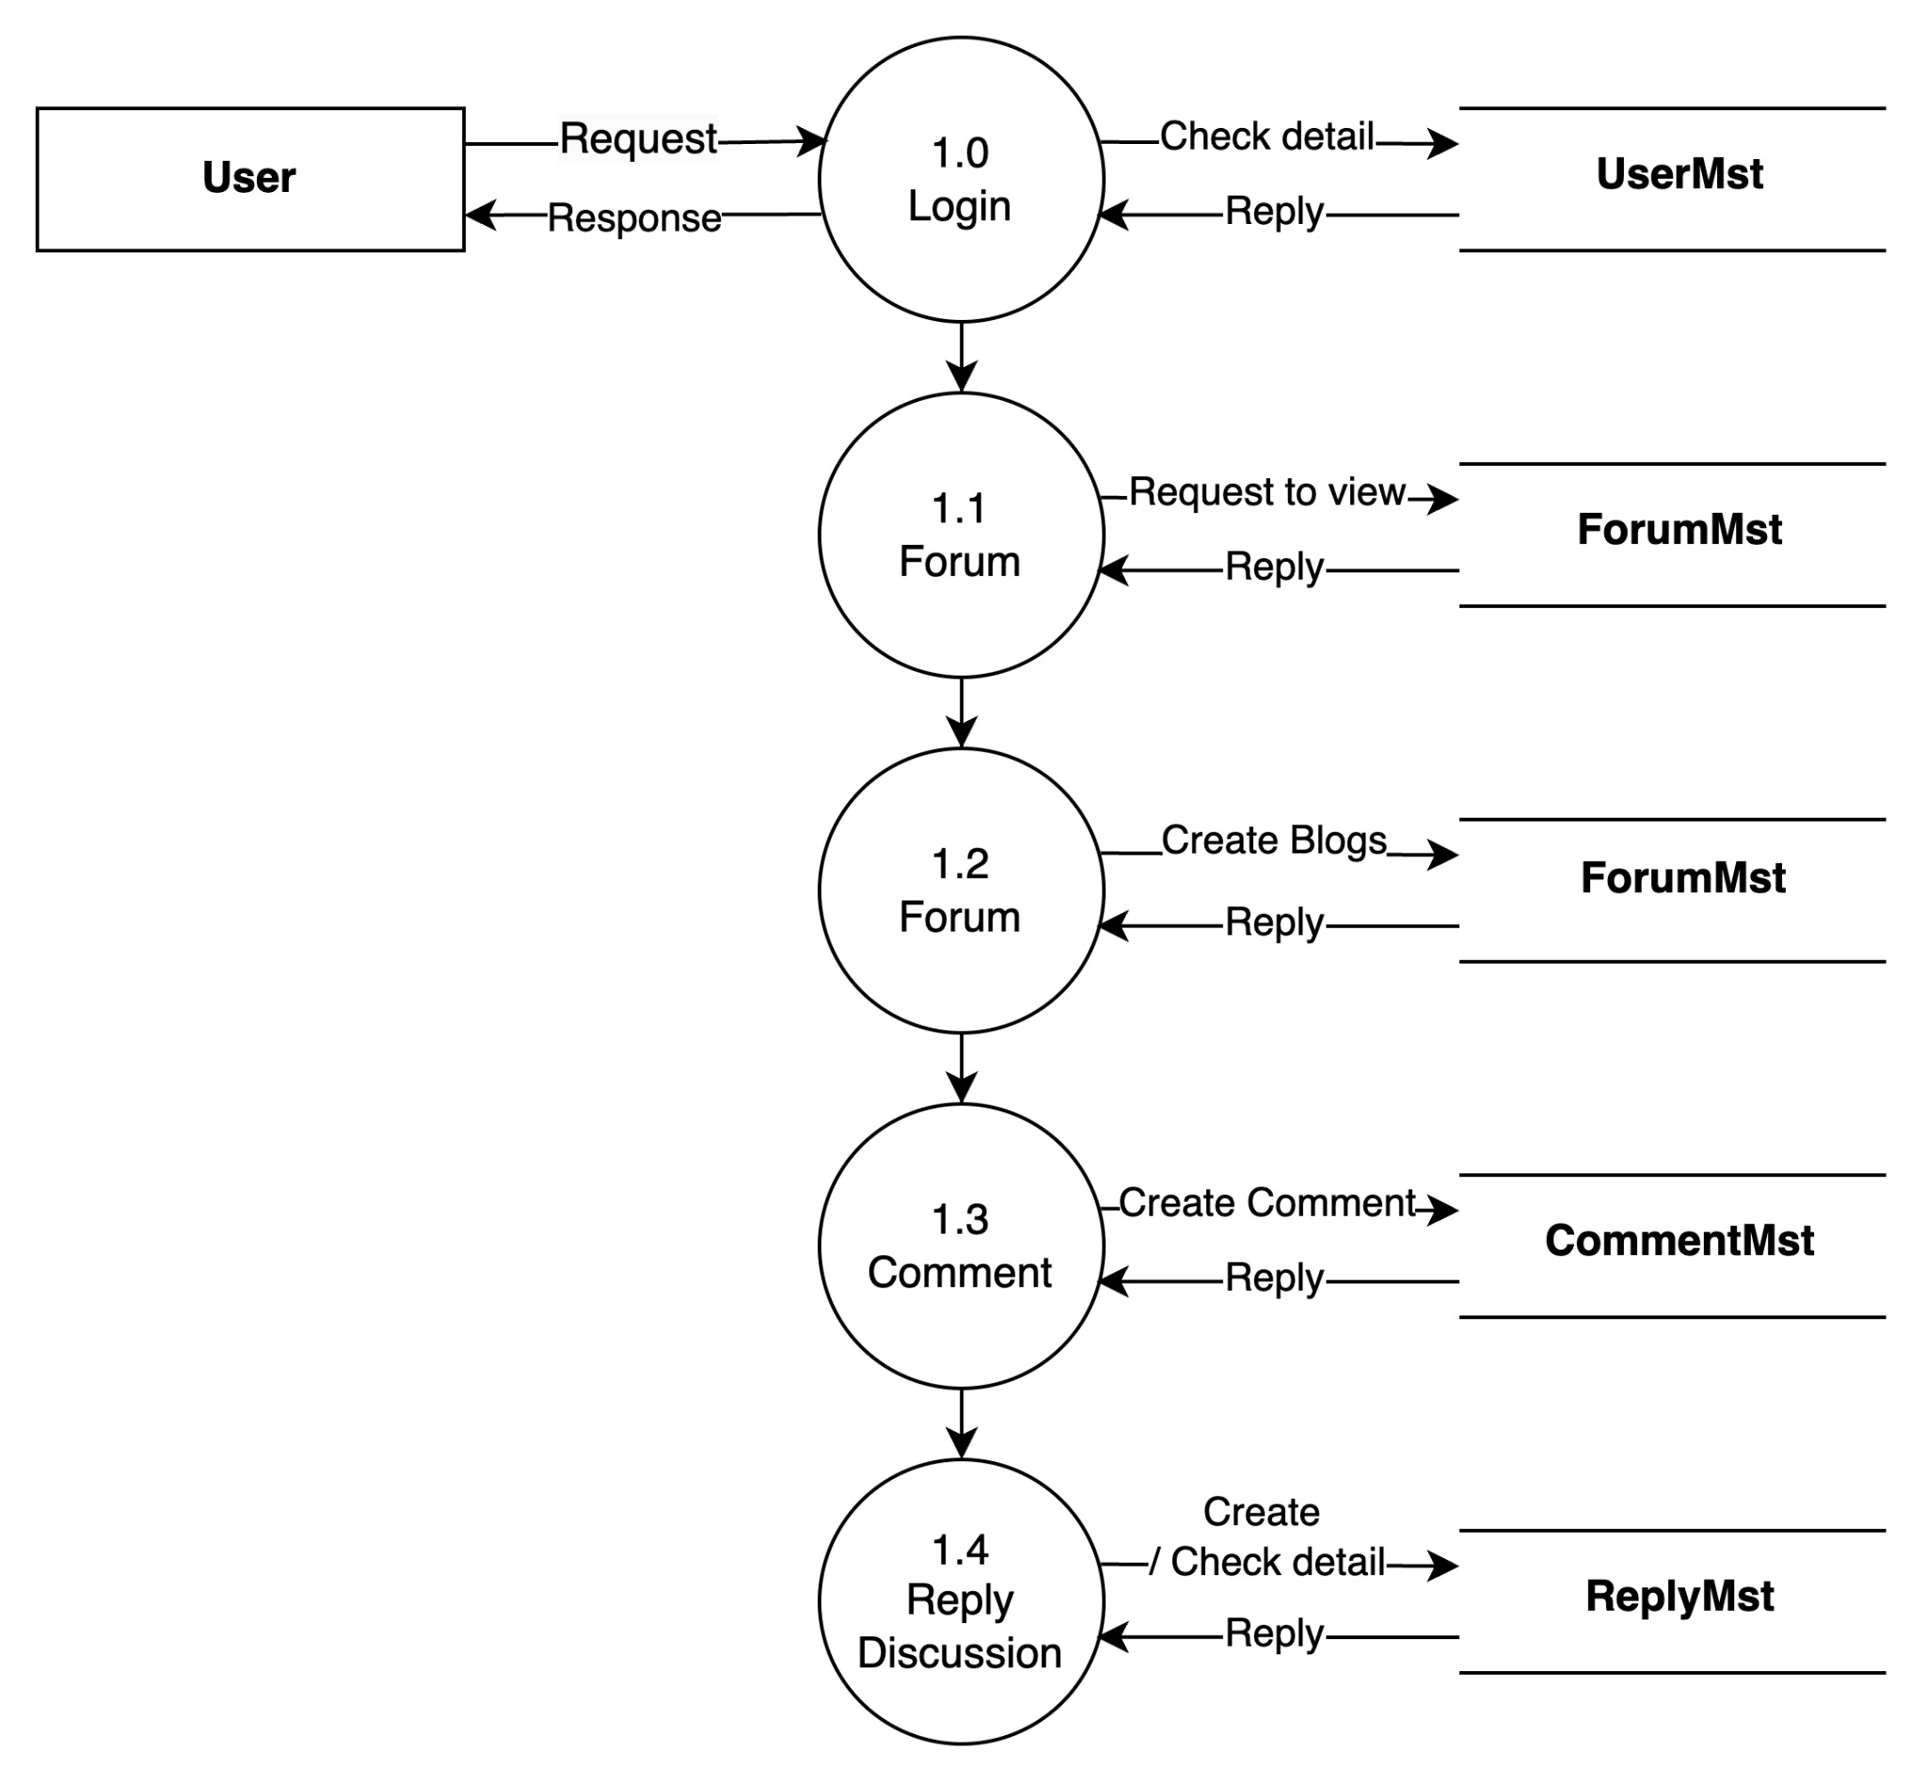

## Flow Charts

* 1. Flow Chart Symbols

| **Symbol** | **Name** | **Function** |
| --- | --- | --- |
|  | **Start or End** | An oval represents a start or end point. |
|  | **Arrows** | A line is a connector that shows relationships between the representative shapes. |
|  | **Input/Output** | A parallelogram represents input or output. |
|  | **Process** | A rectangle represents a process. |
|  | **Decision** | A diamond indicates a decision. |
|  | **Display** | A display symbol within a flowchart indicates where the chart is to display the data within a process to a user. |

* 1. Flow Charts

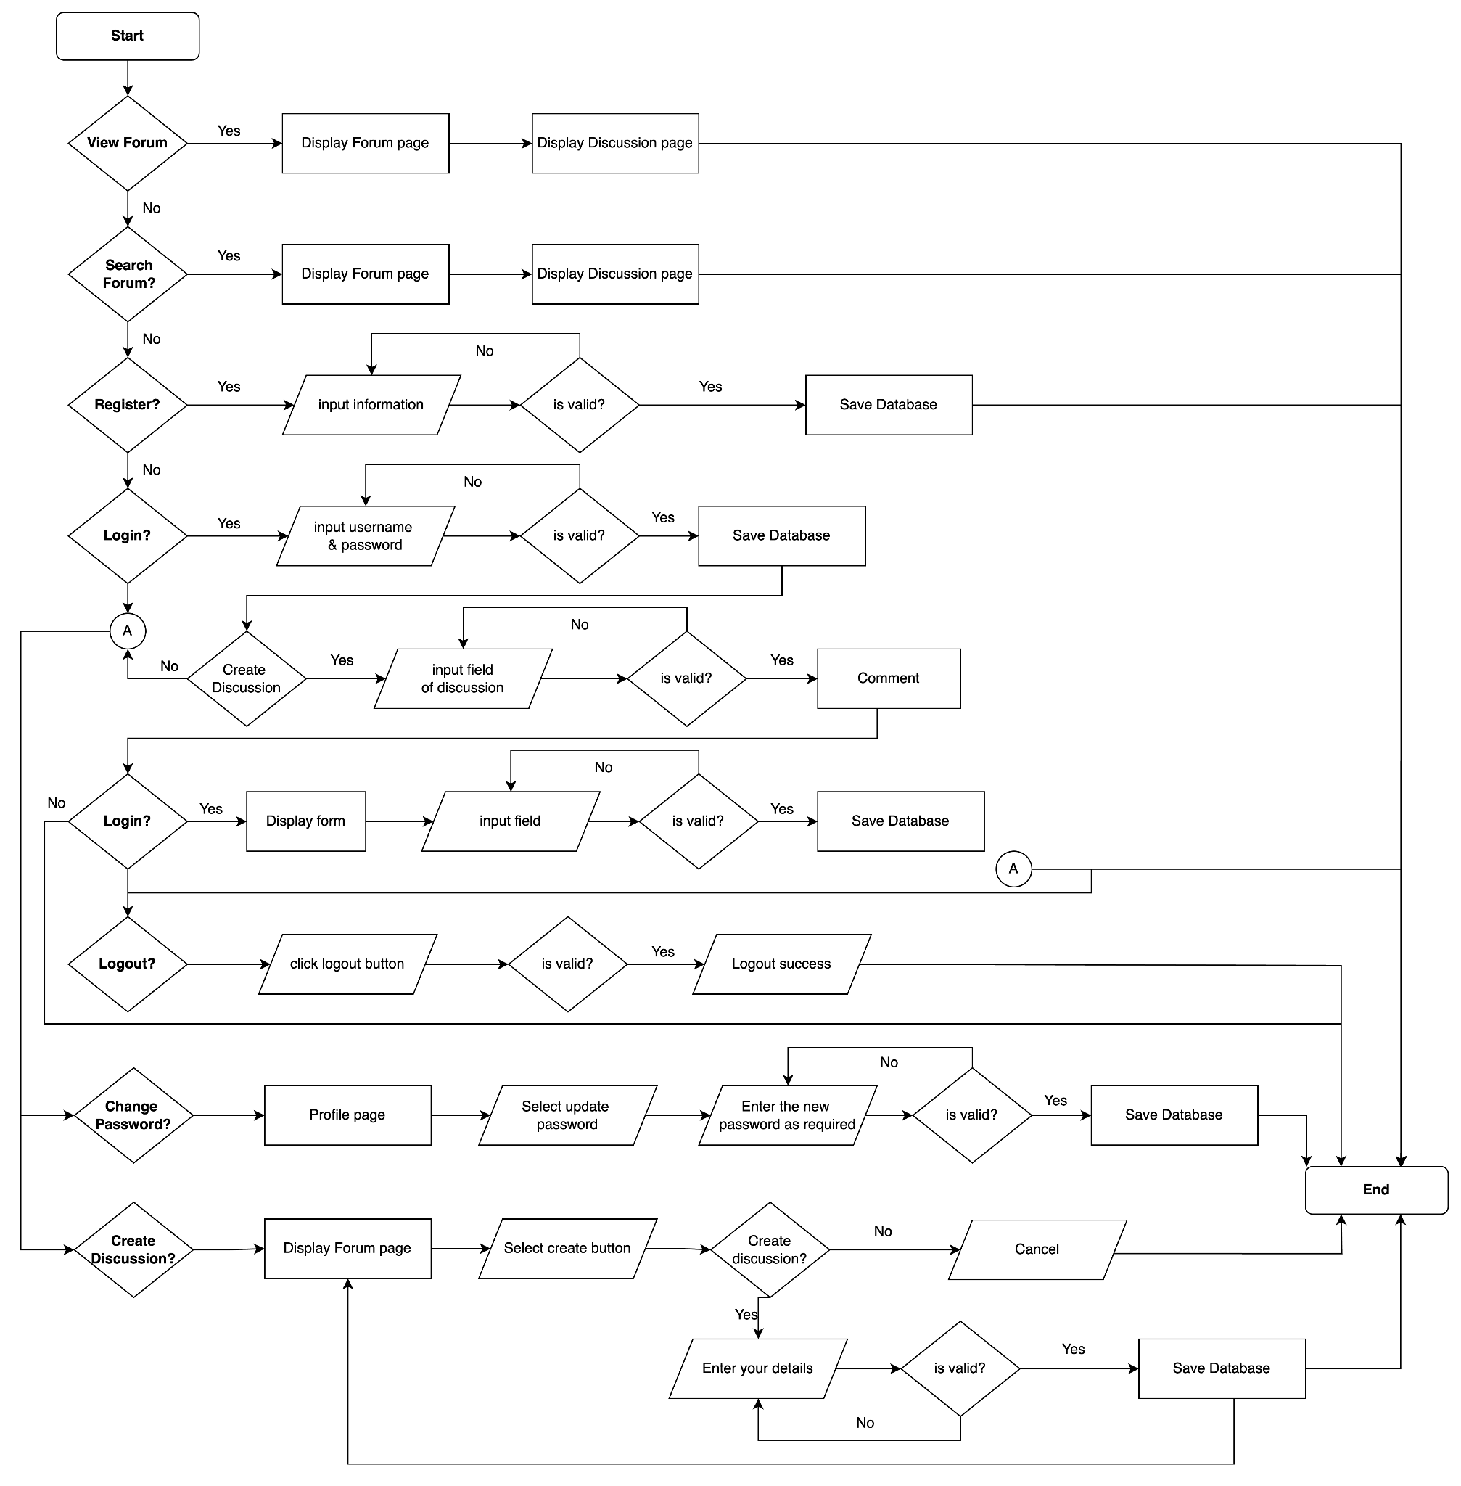

### Register *process* (for users, admin, moderators)

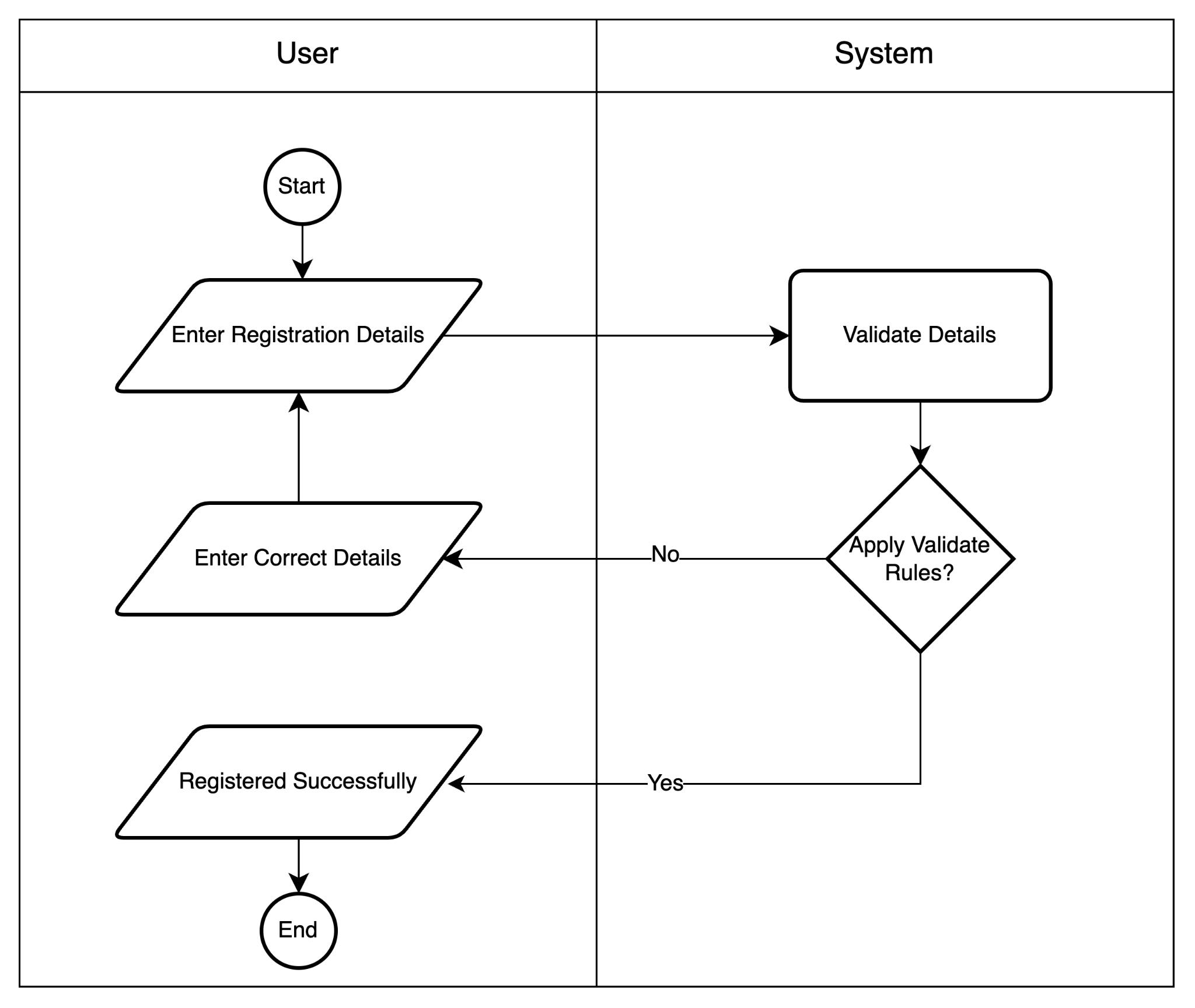

### Login *process* (for users, admin, moderators)

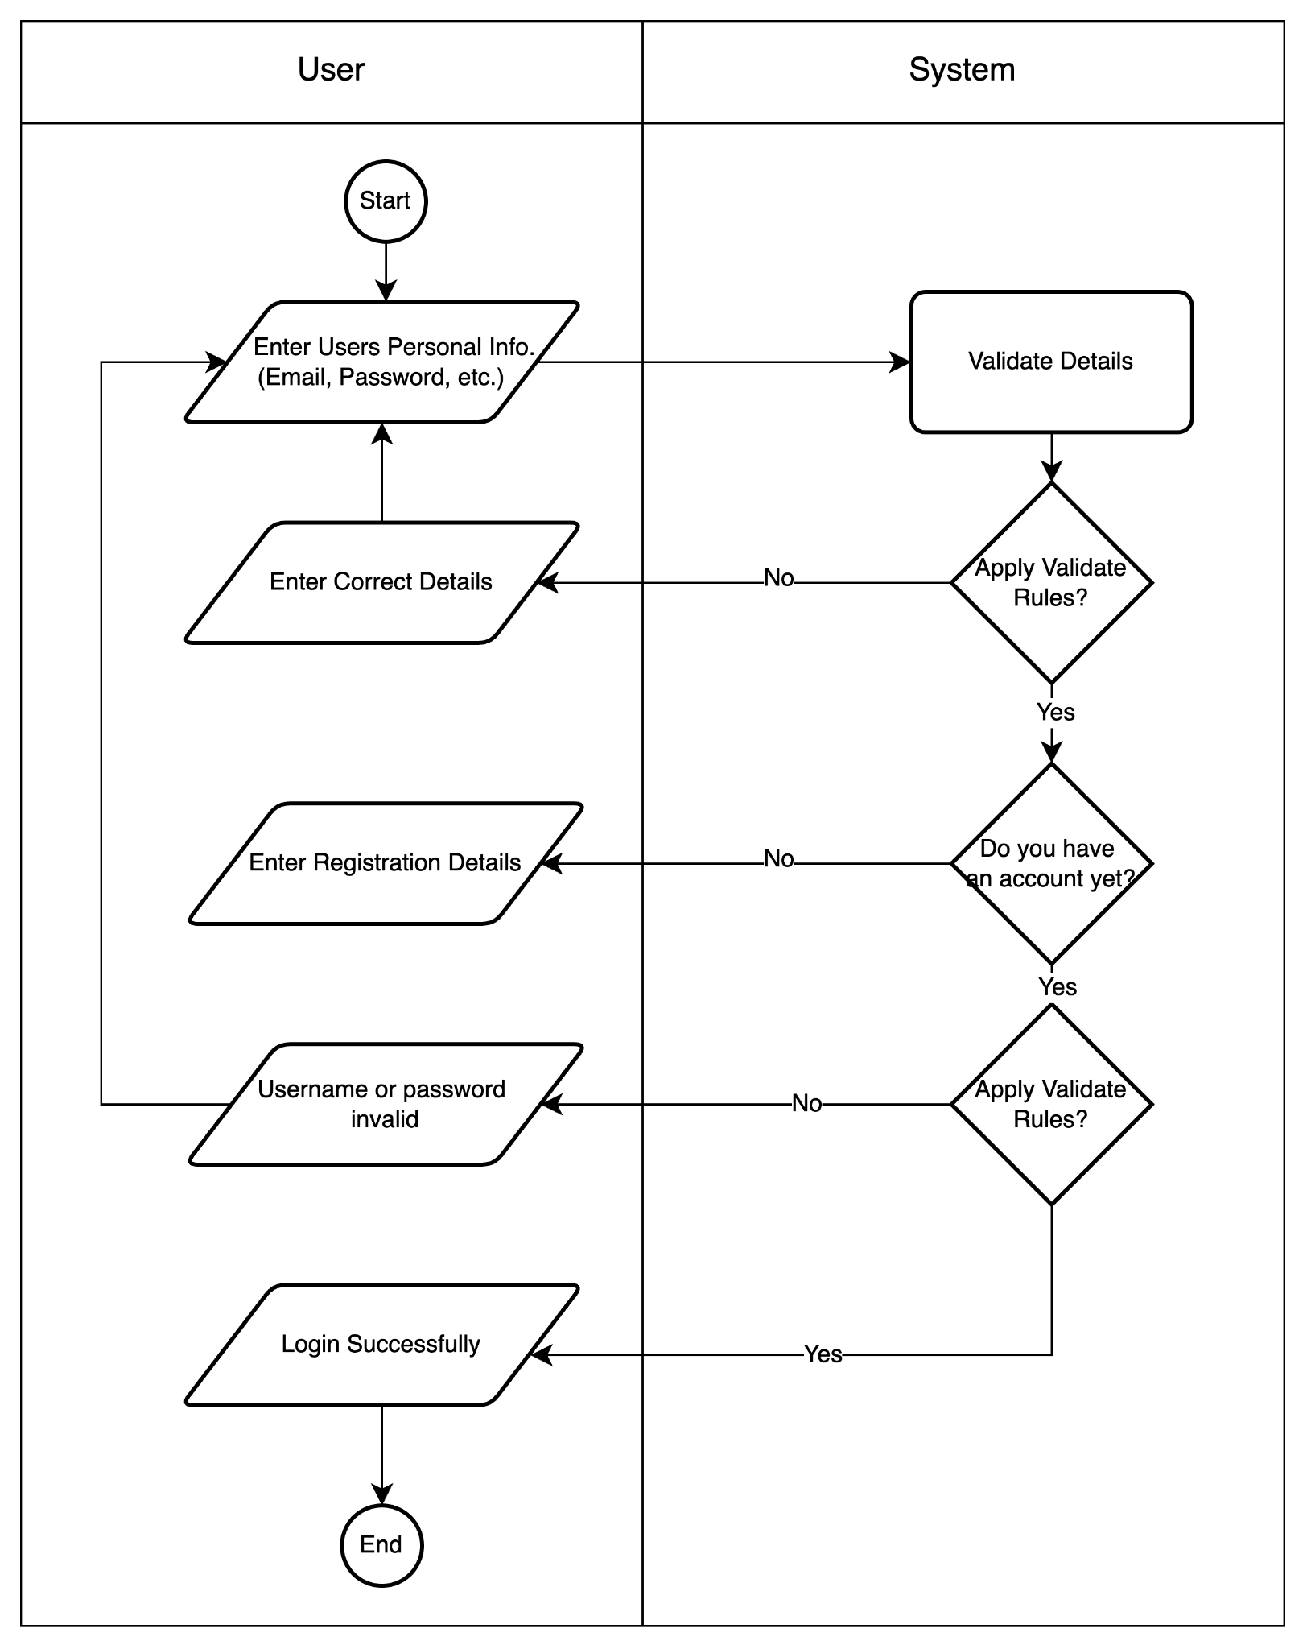

### Logout *process* (for users, admin, moderators)

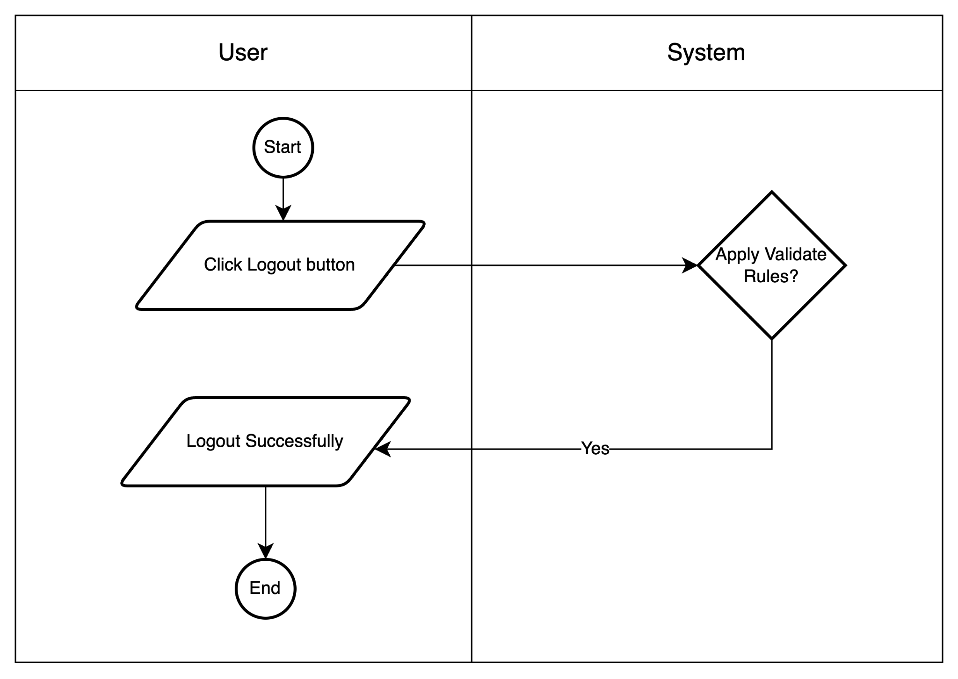

### Update the *profile's* information process (for users, admin, moderators)

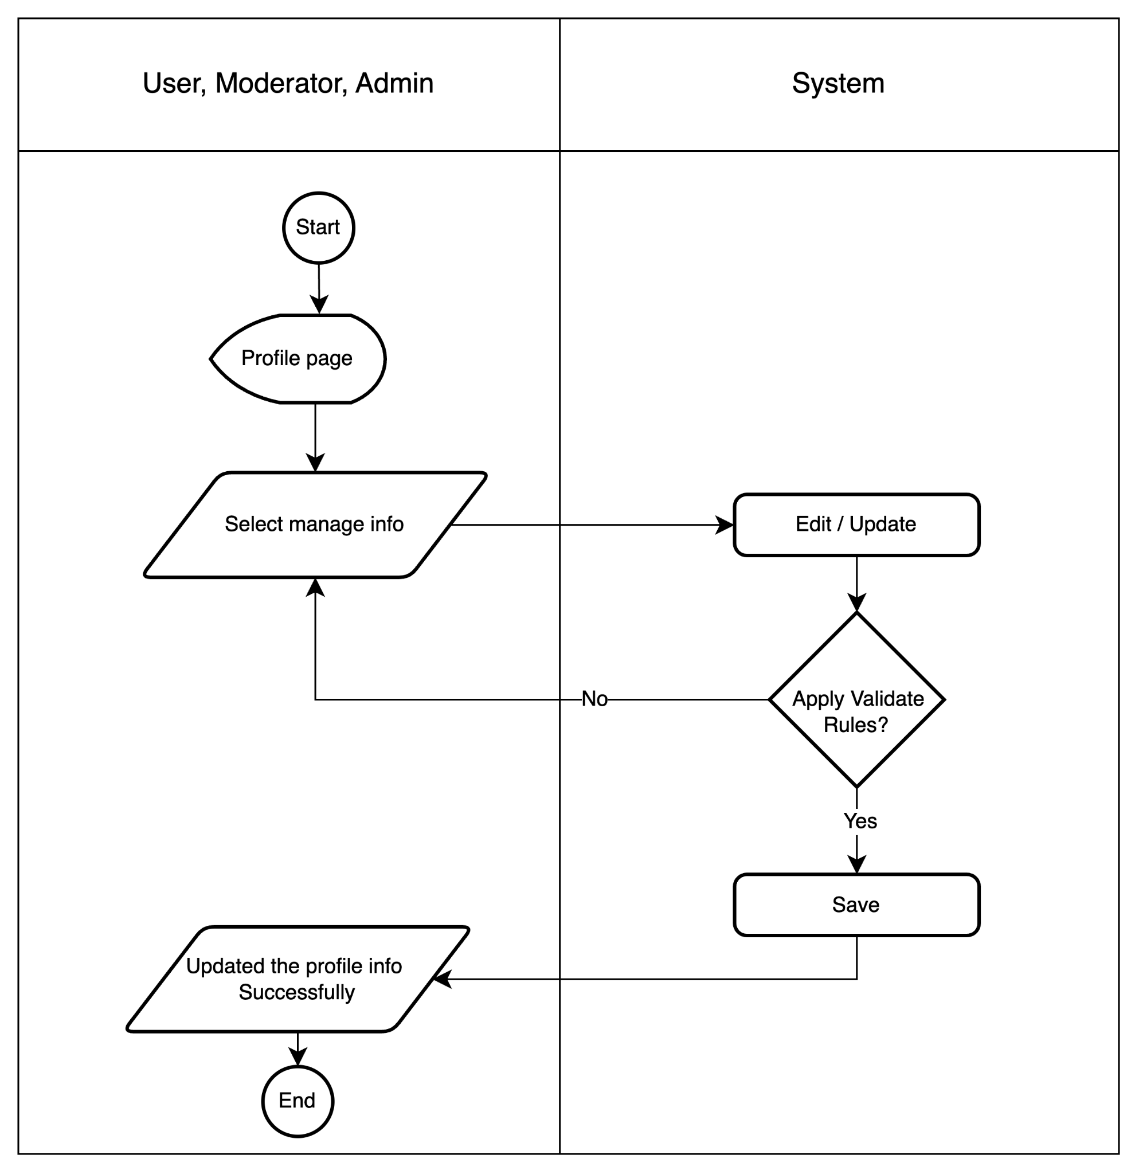

### Change password *process* (for users, admin, moderators)

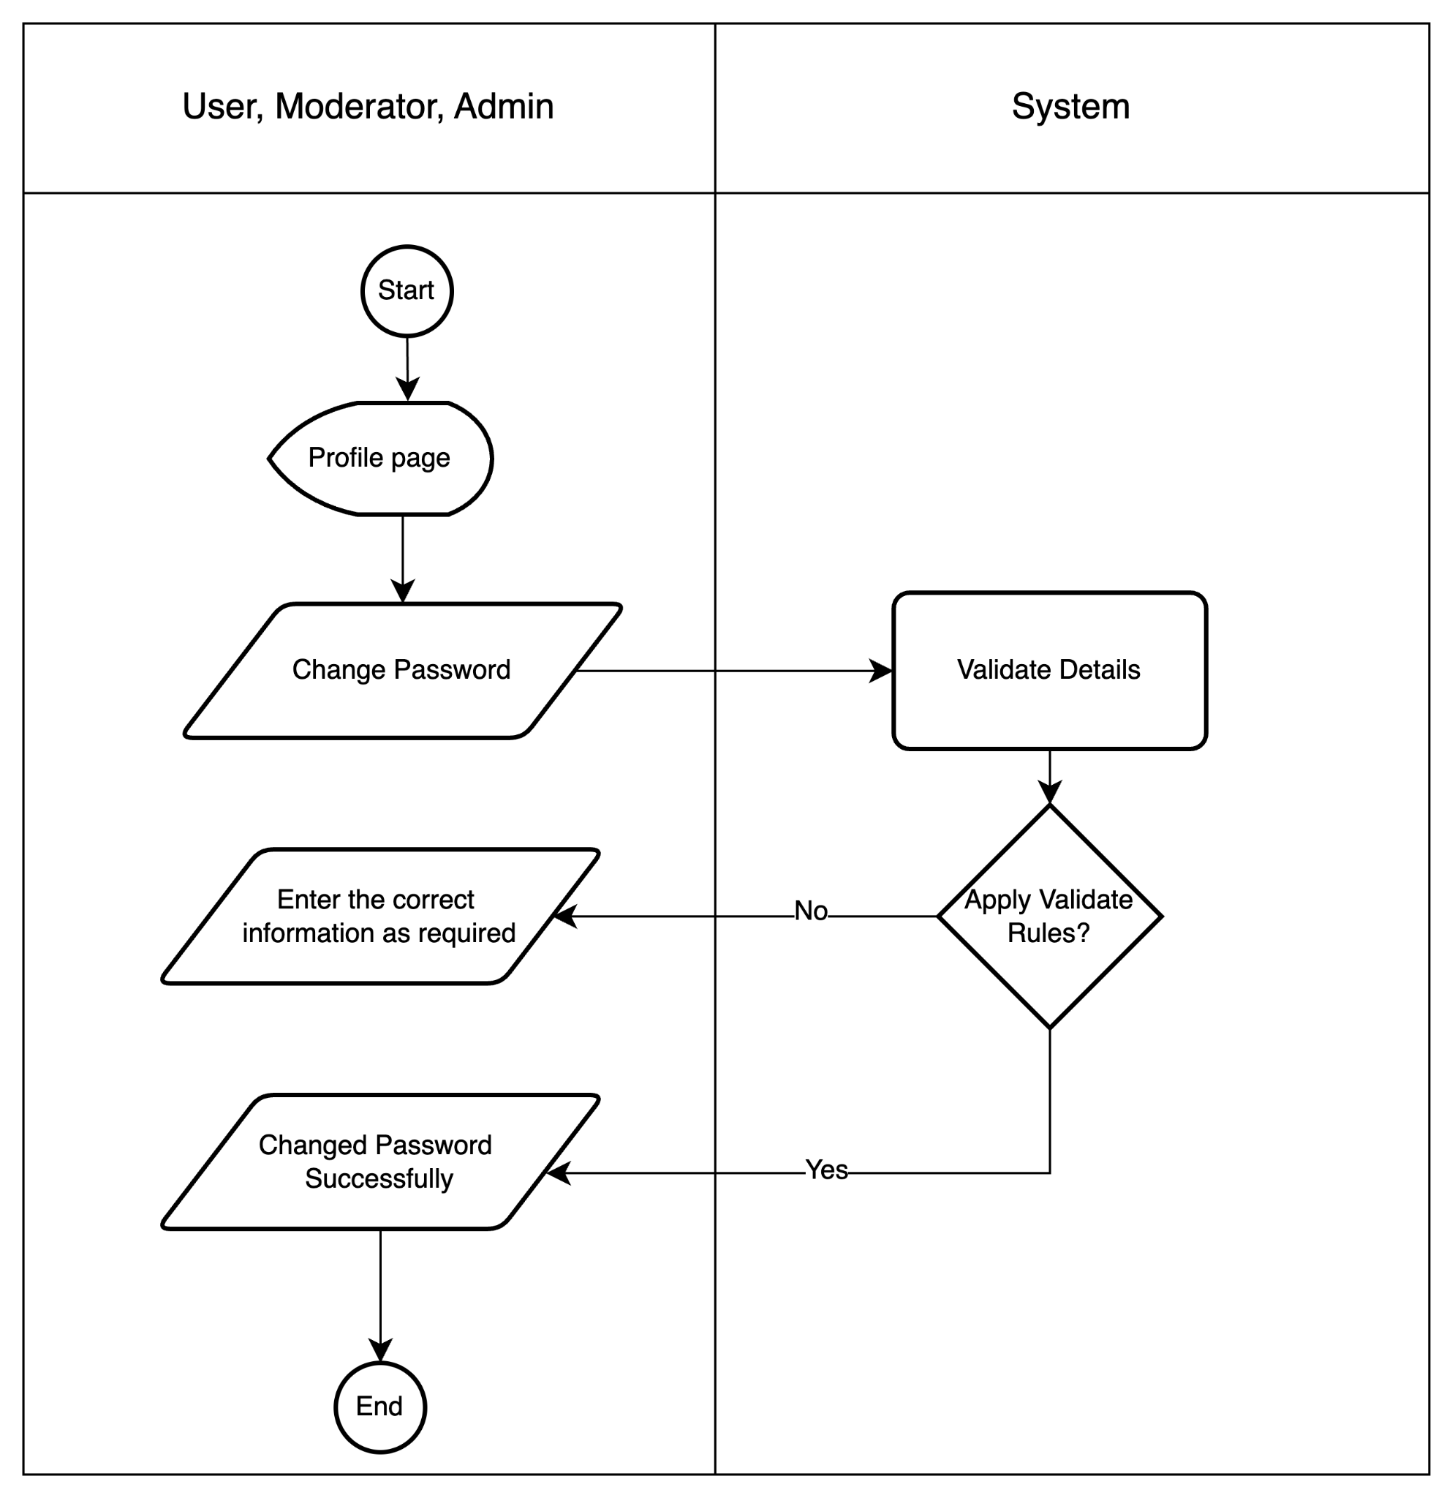

### Create Discussion/Blog/Feedback in forum *process* (for users, admin)

## Entity Relationship Diagram - ERD

* 1. Entity – Relationship Diagram Symbols

|  | Representing an entity |
| --- | --- |
|  | Representing a relationship between two entities |
|  | An attribute of an entity |
|  | This attribute is the primary key |

### 

### 

* 1. Entity – Relationship Diagram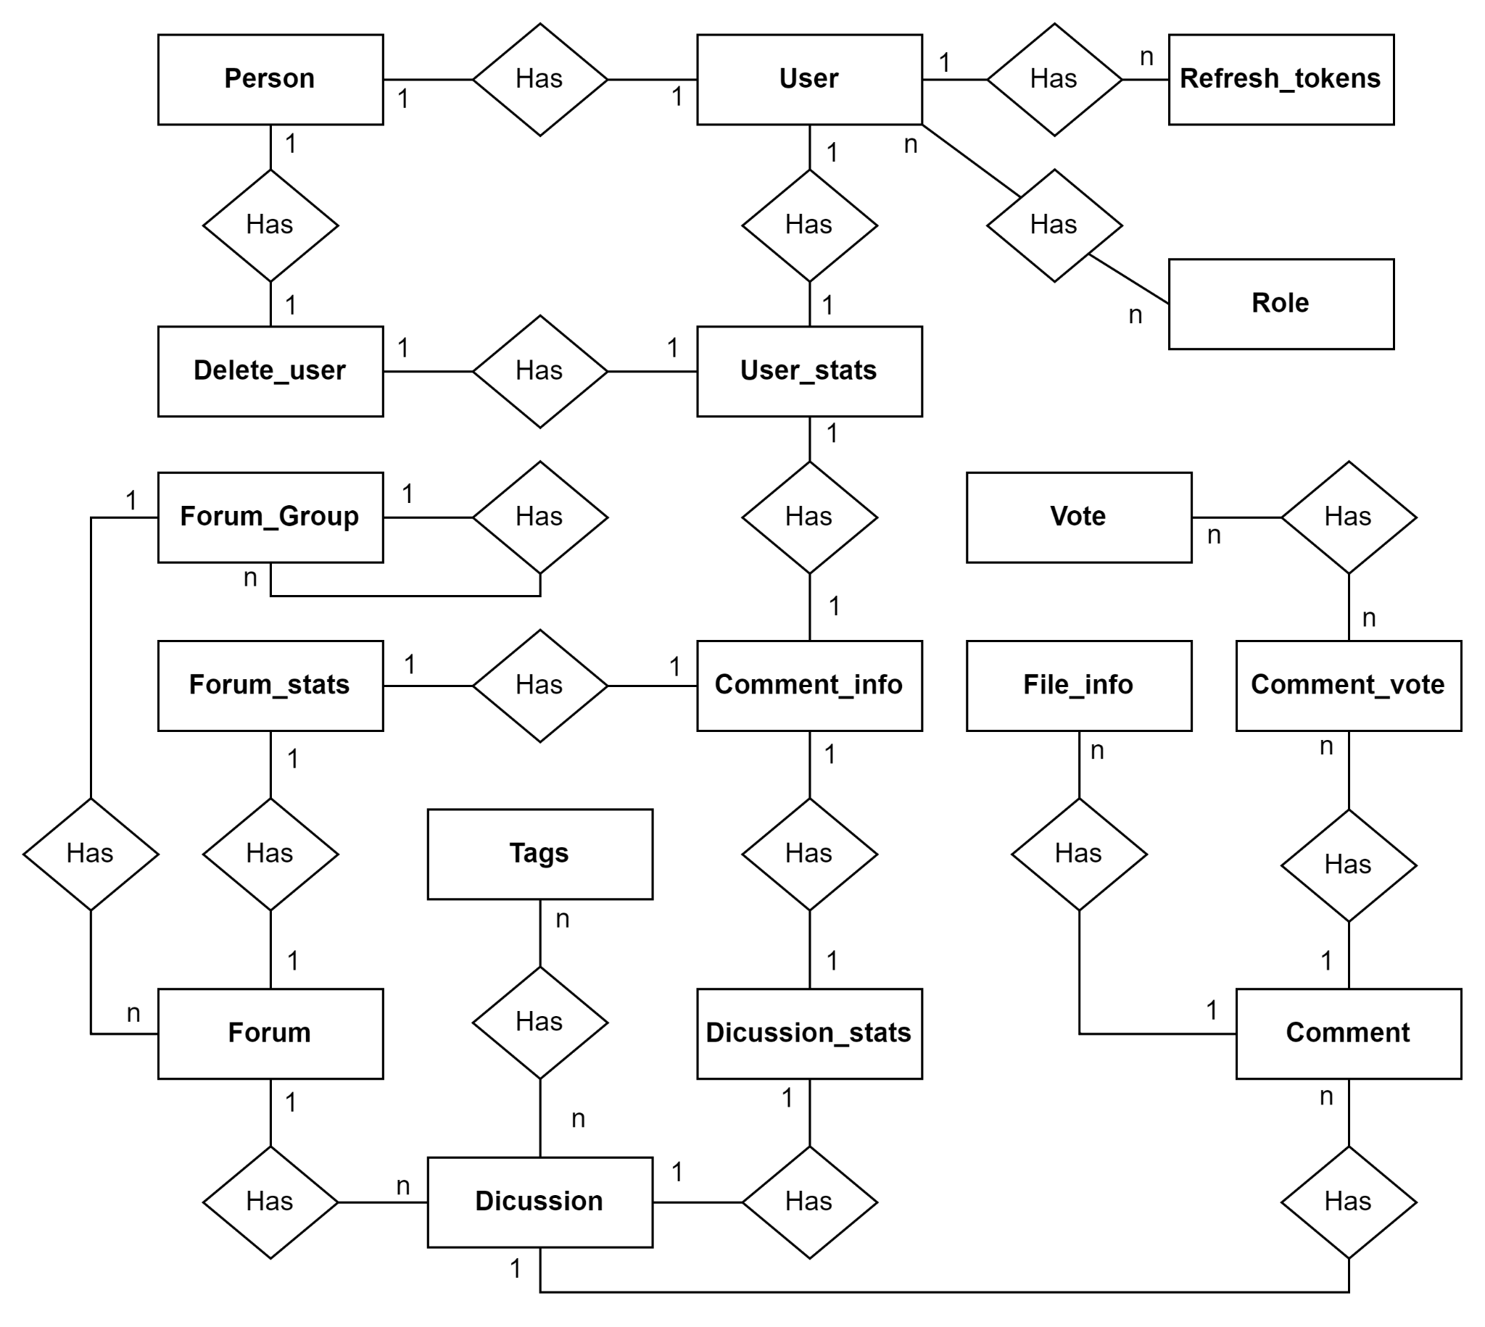
  2. Entities and Properties
     1. User Entity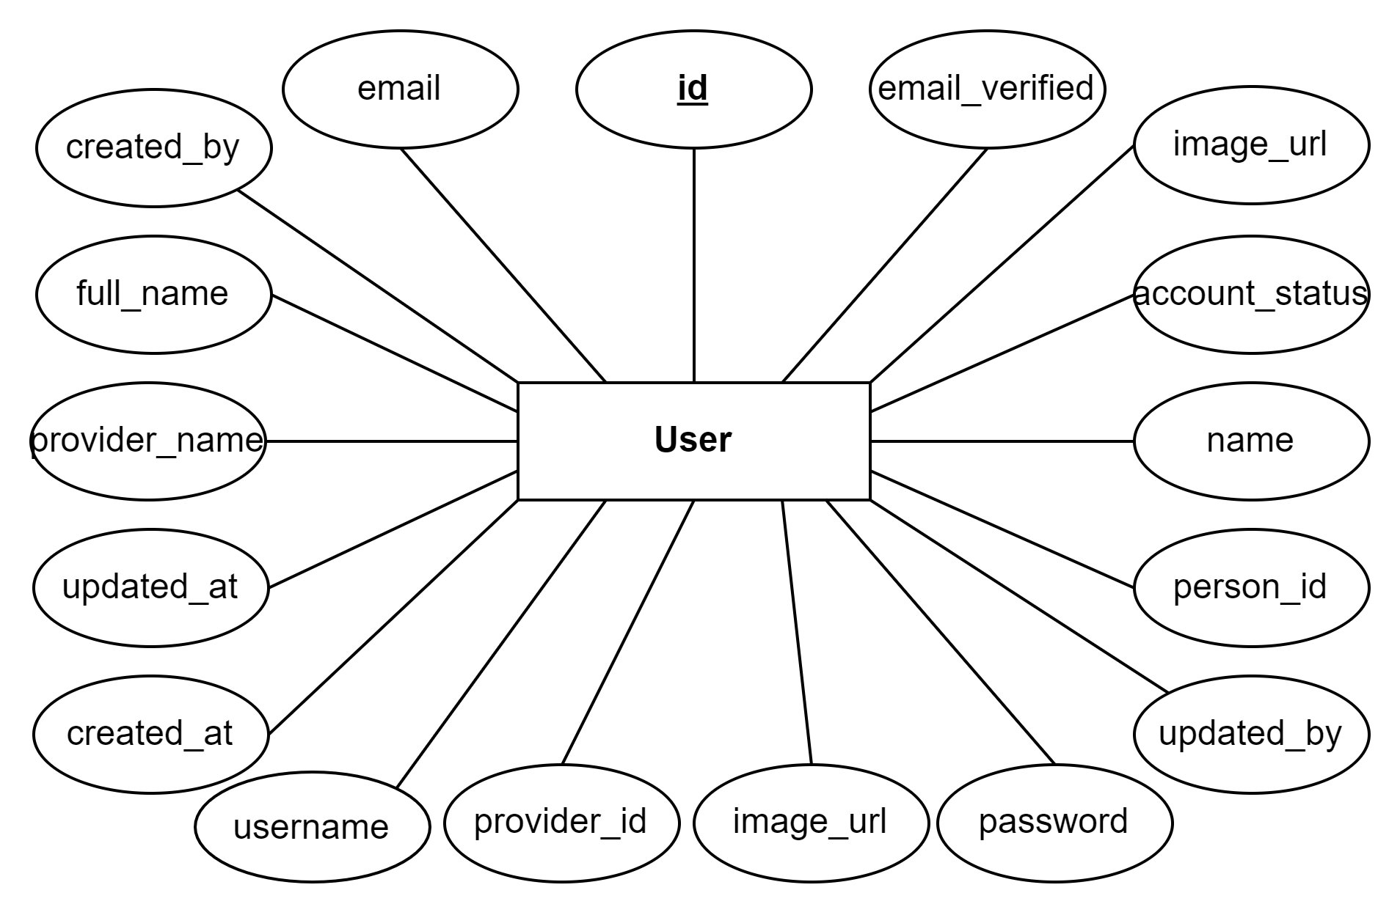
     2. **Person Entity**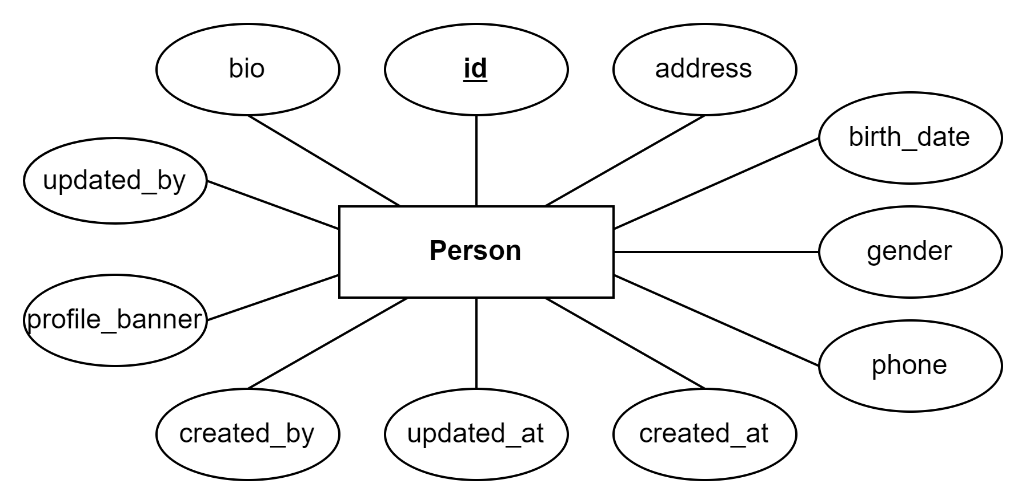
     3. **Roles Entity**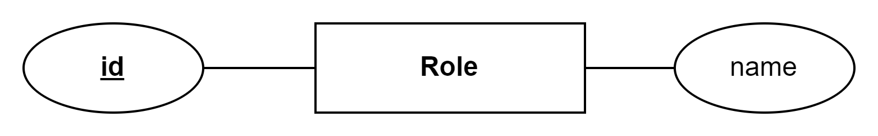

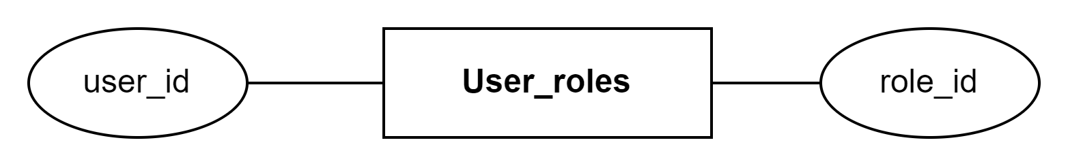

* + 1. **RefreshToken Entity**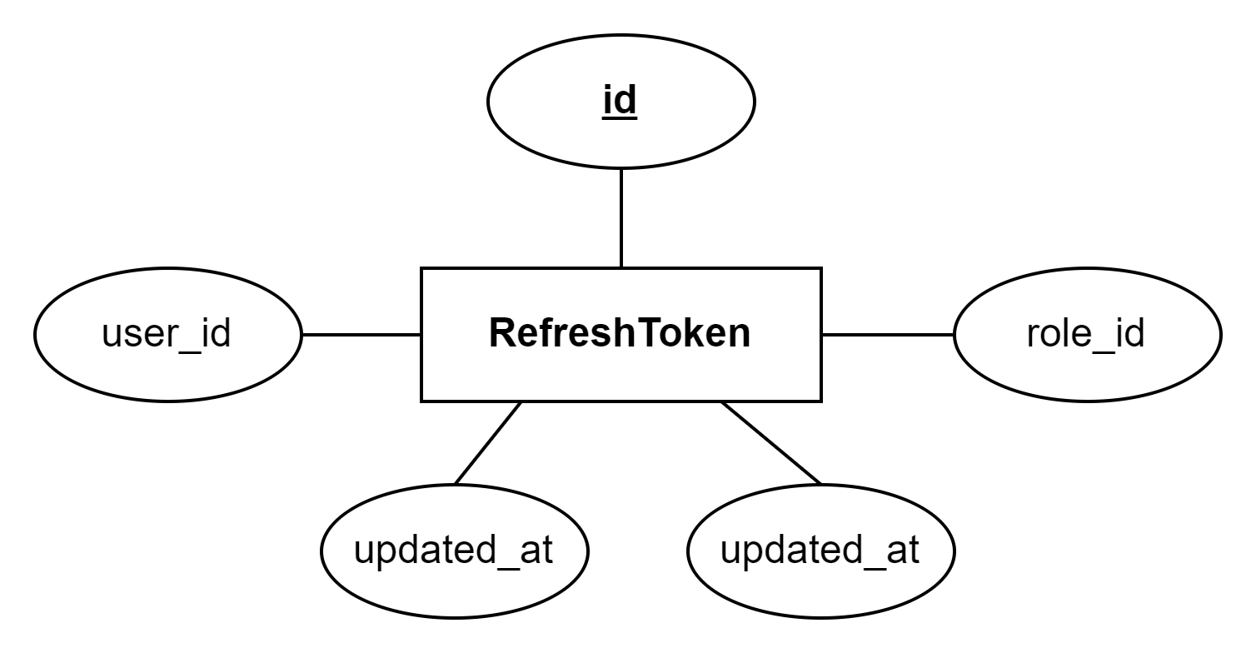
    2. **User_stats Entity**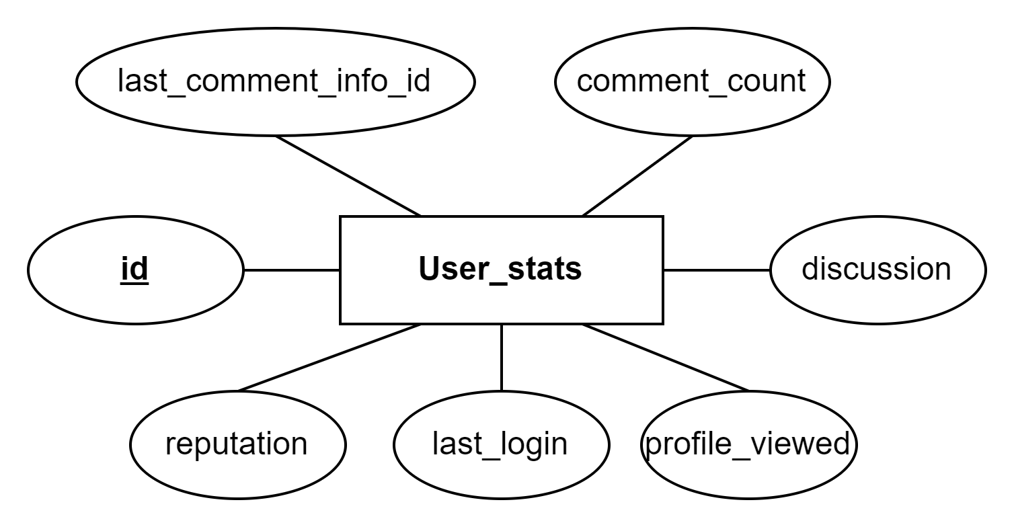
    3. **Forum Group Entity**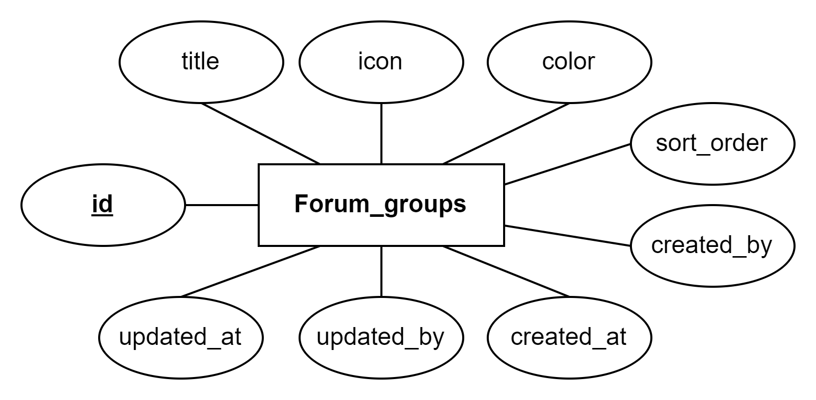
    4. **Forum Entity**

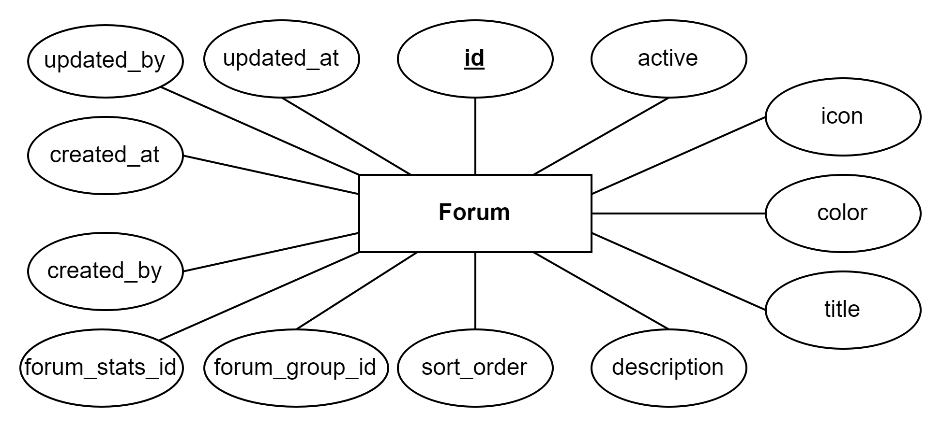

* + 1. ***Forum* stats *Entity***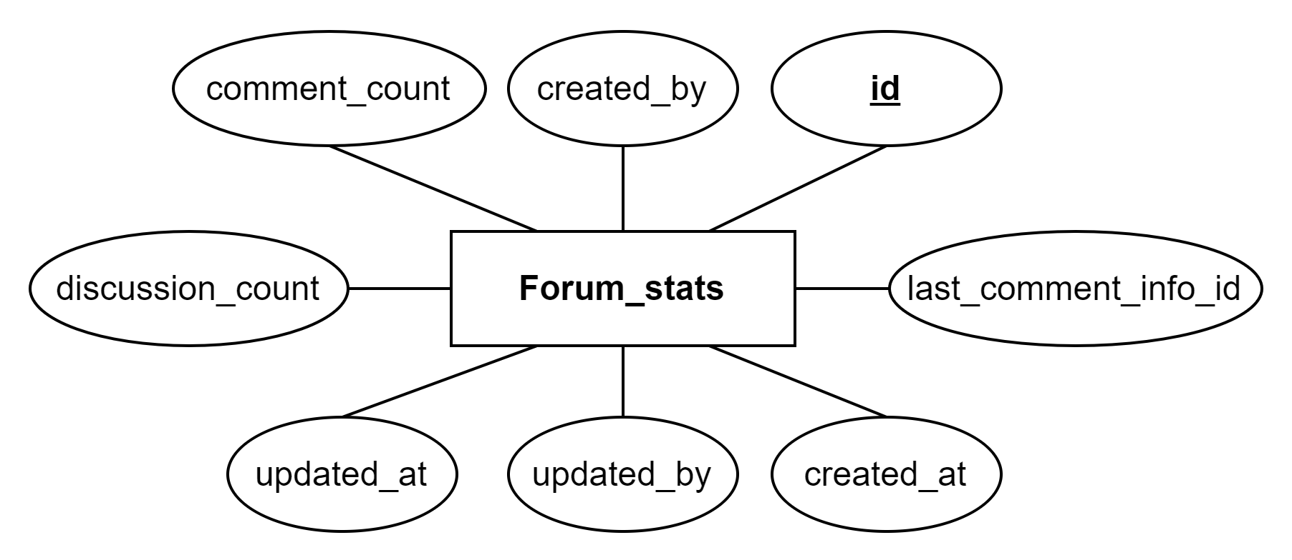
    2. **Discussions *Entity***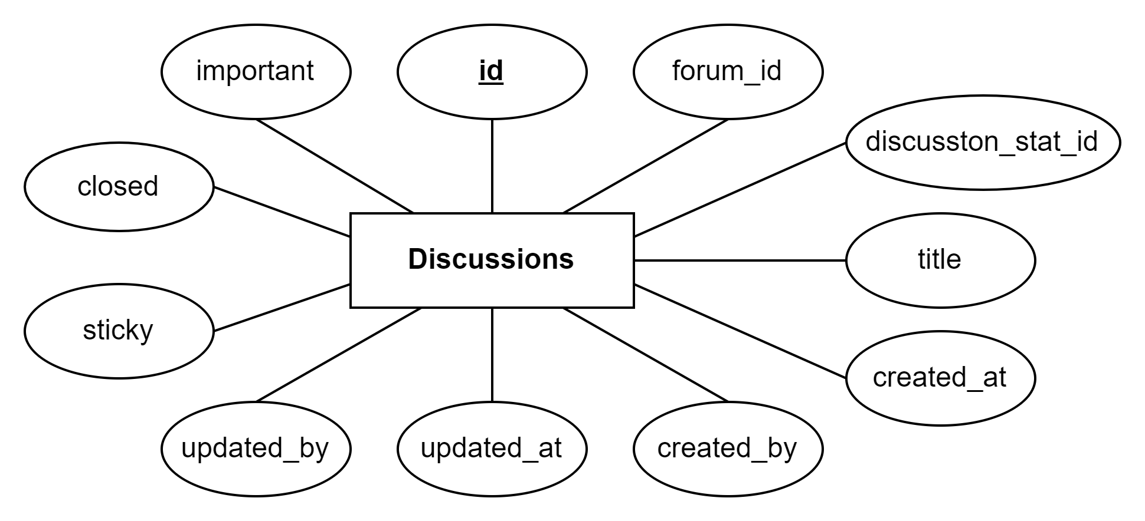
    3. ***Discussion* Stats *Entity***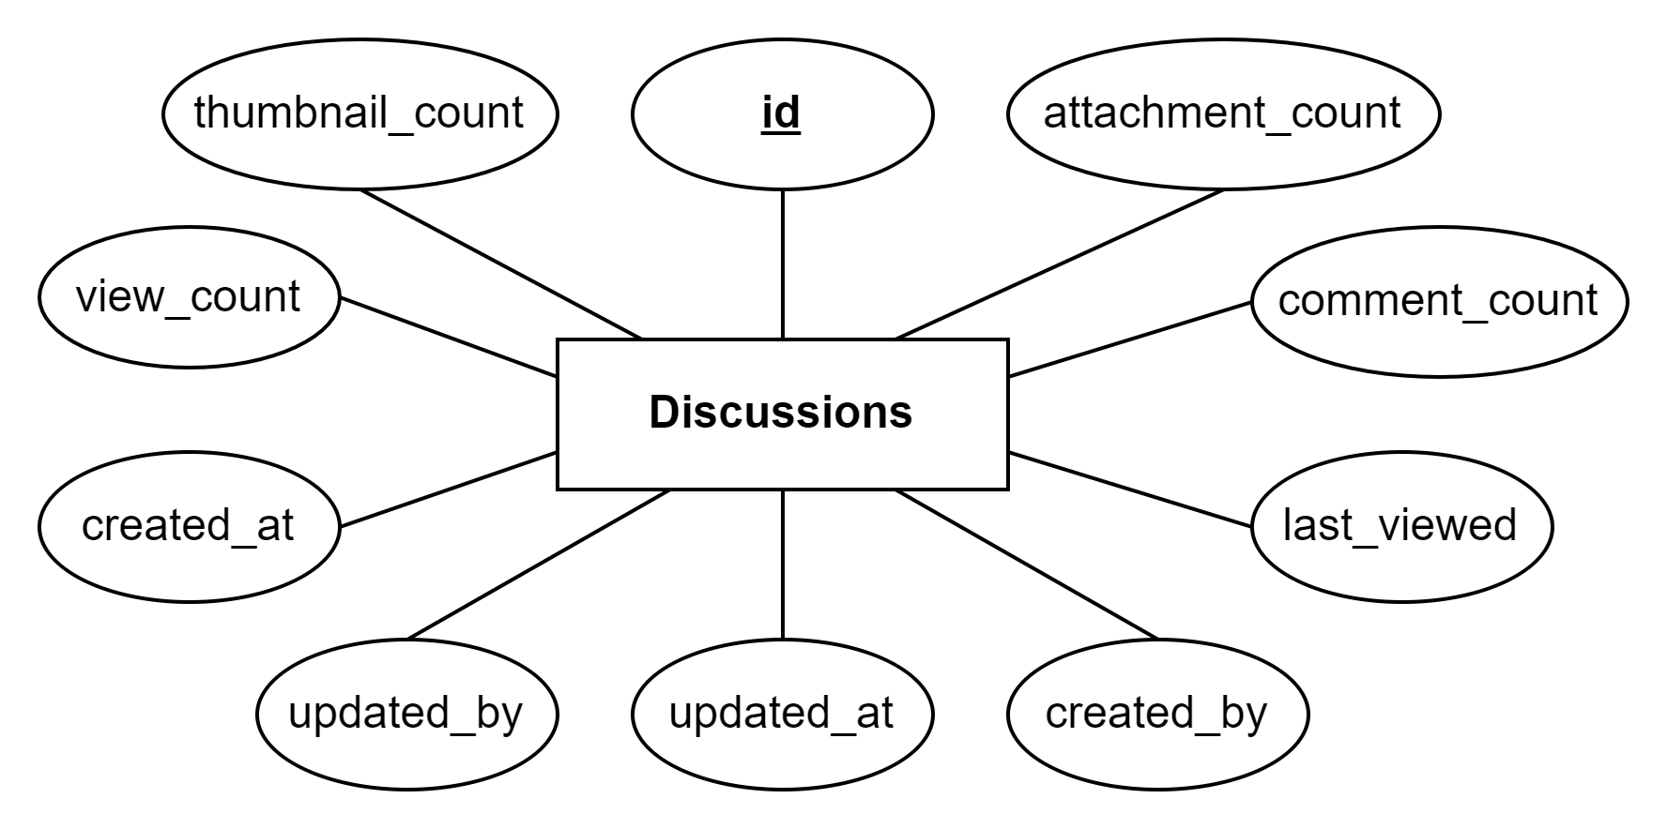
    4. ***Comment-*info *Entity***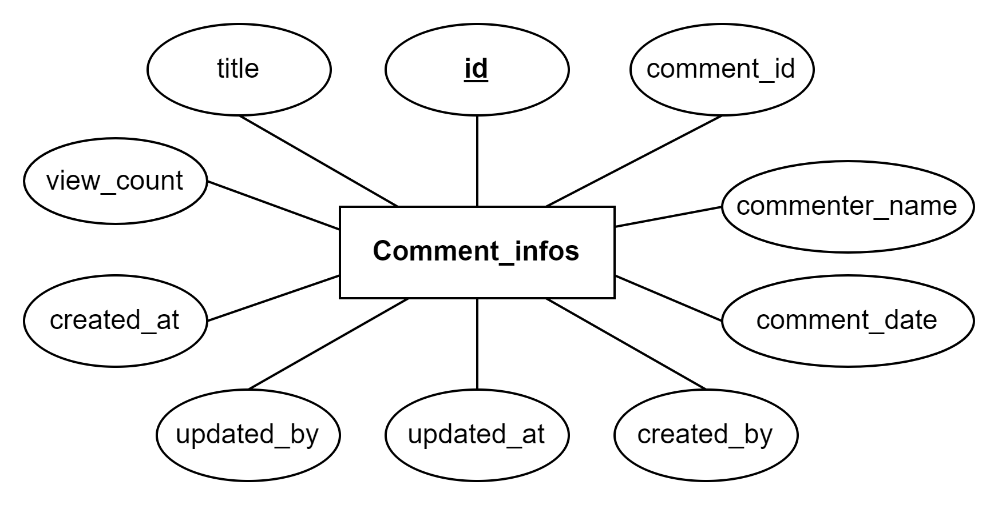
    5. **Comment *Entity***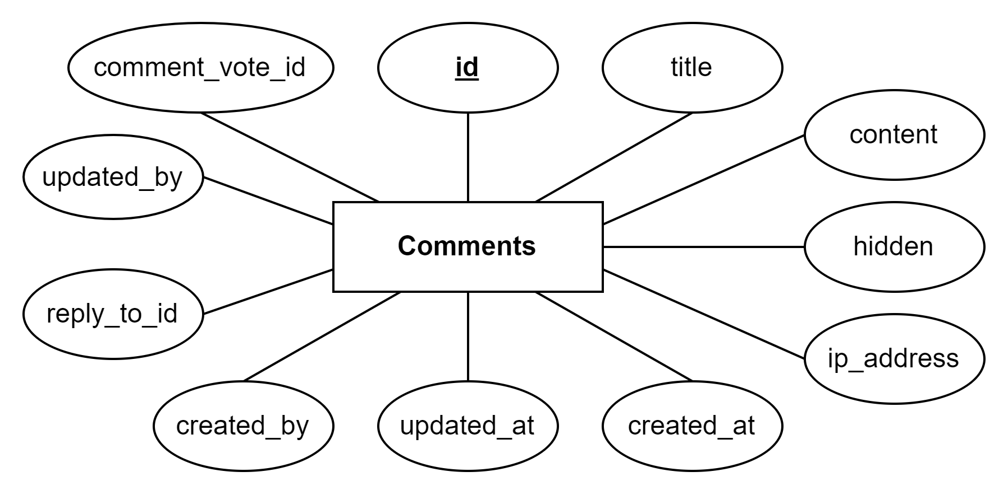
    6. **Comment*-votes Entity***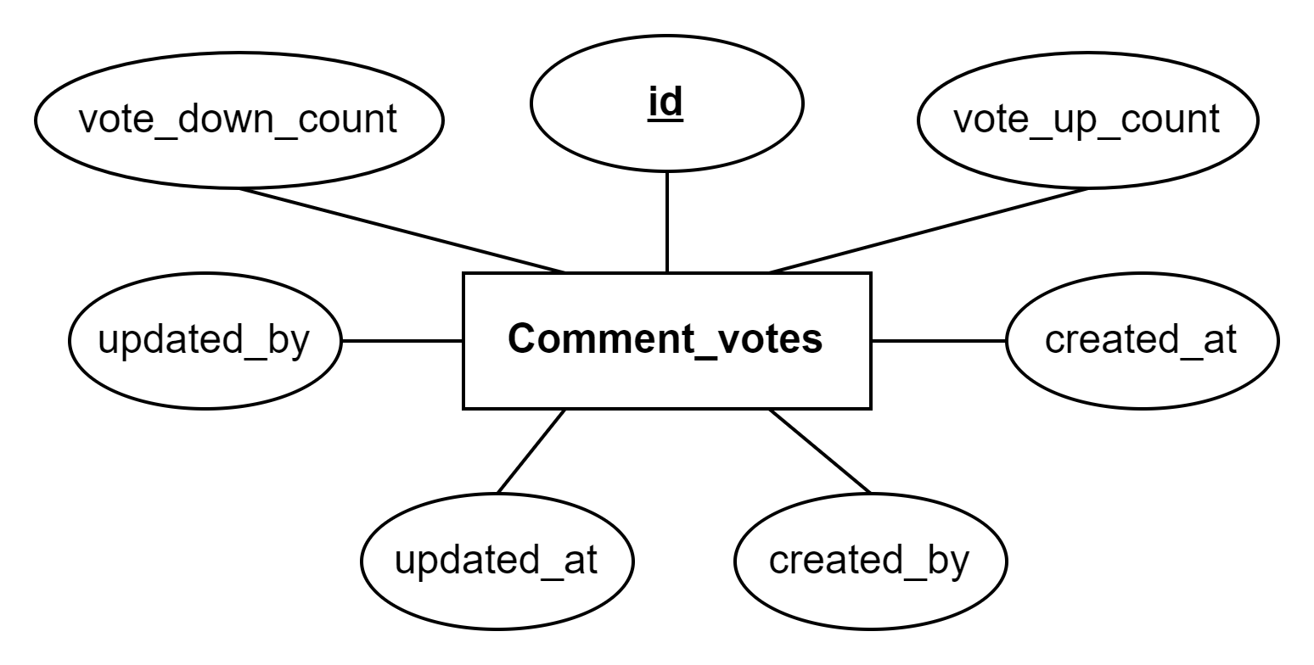
    7. ***Votes* *Entity***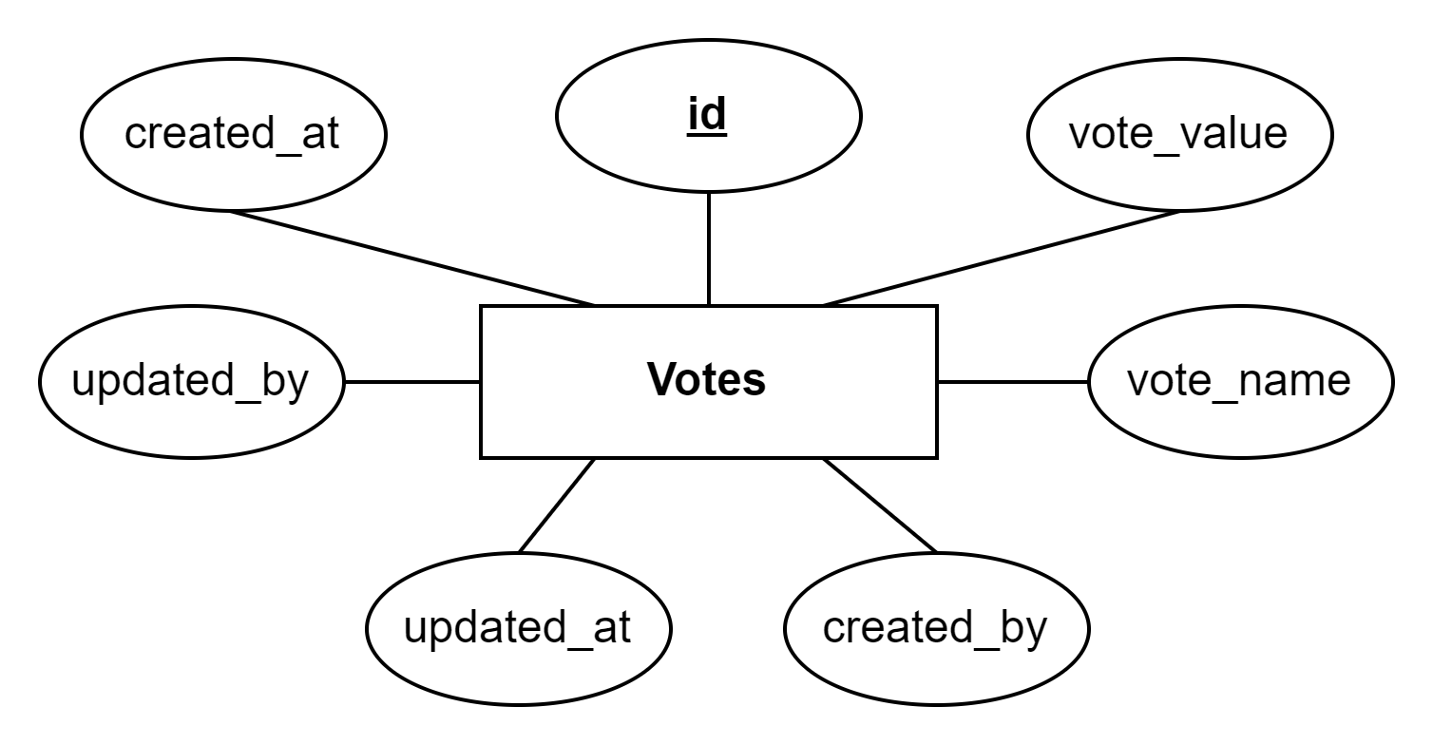
    8. ***Tags* Entity**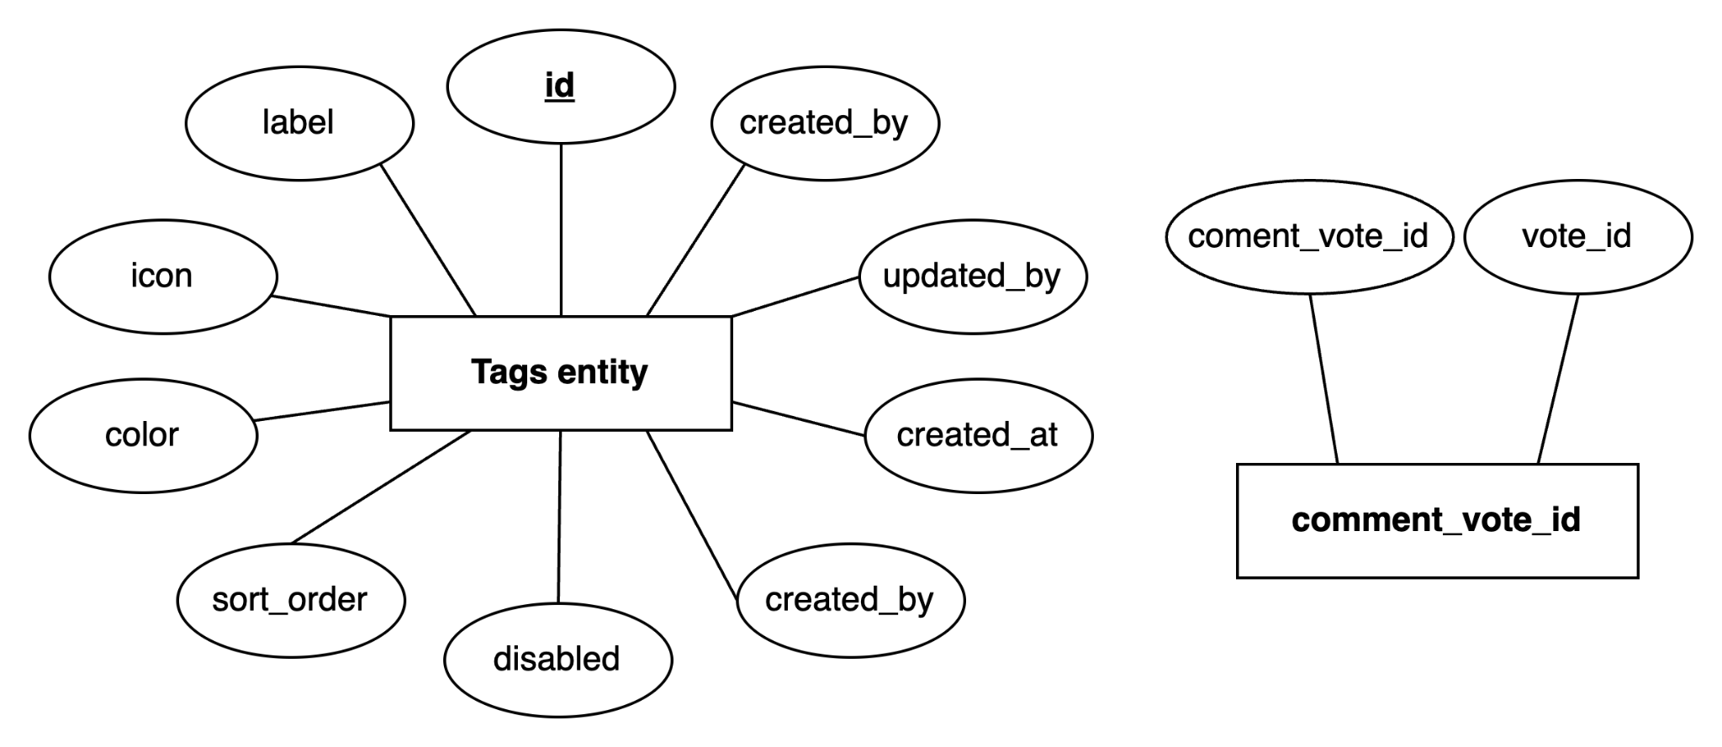
    9. **File*-Info Entity***

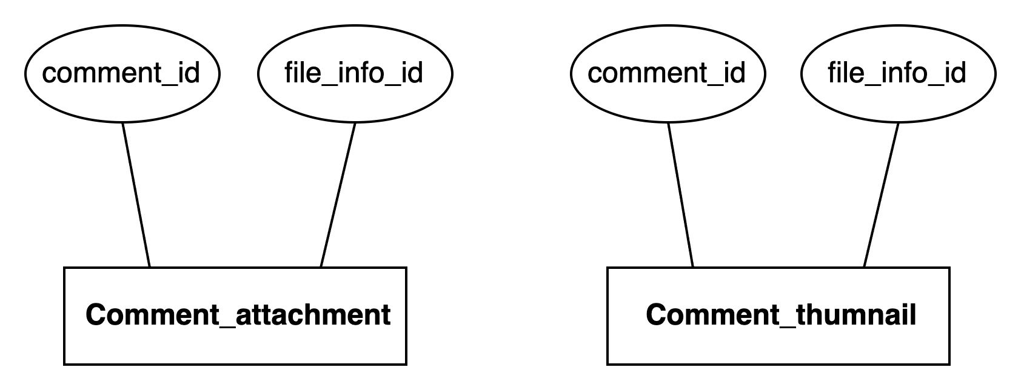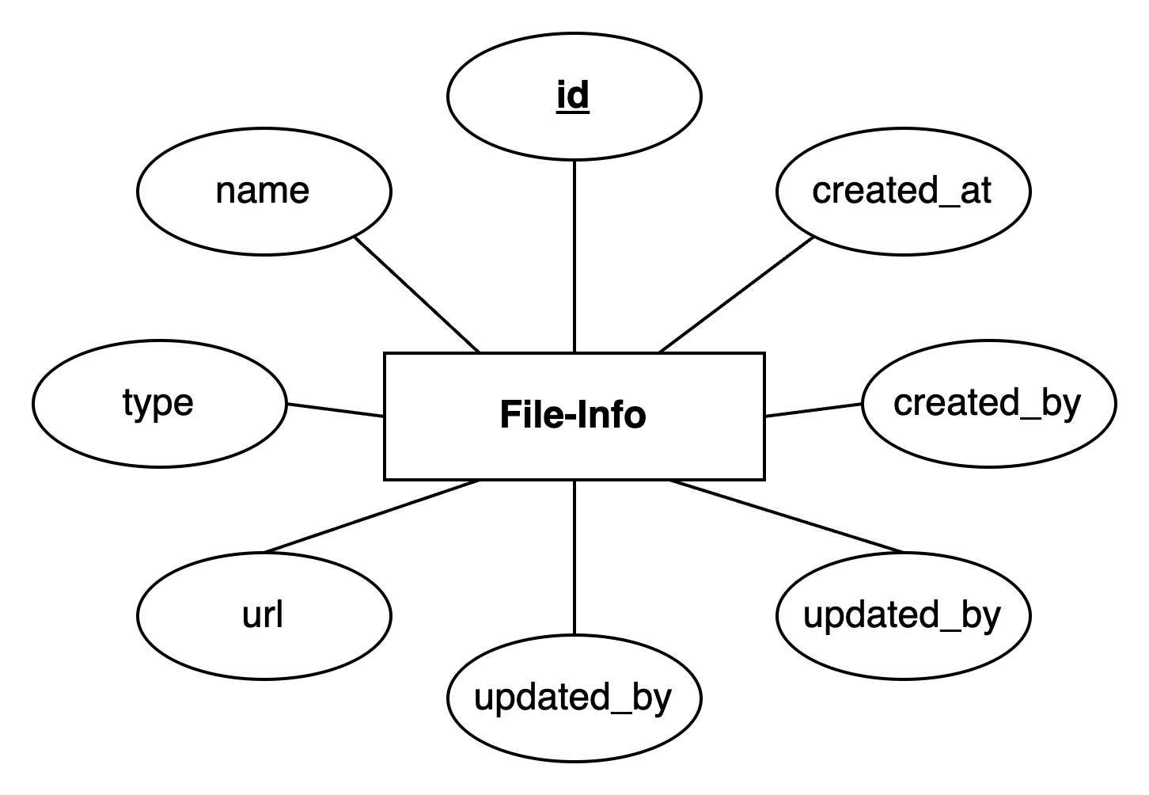

* + 1. **Badges *Entity***

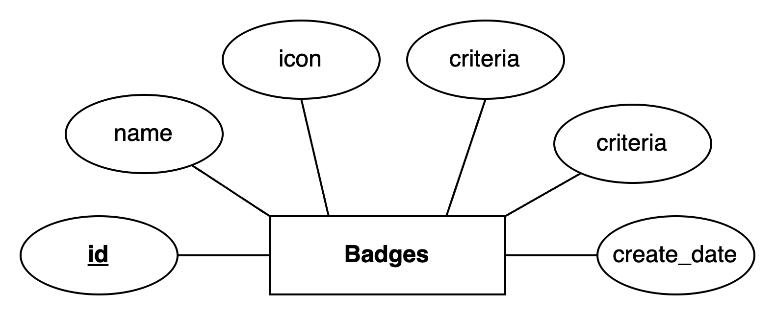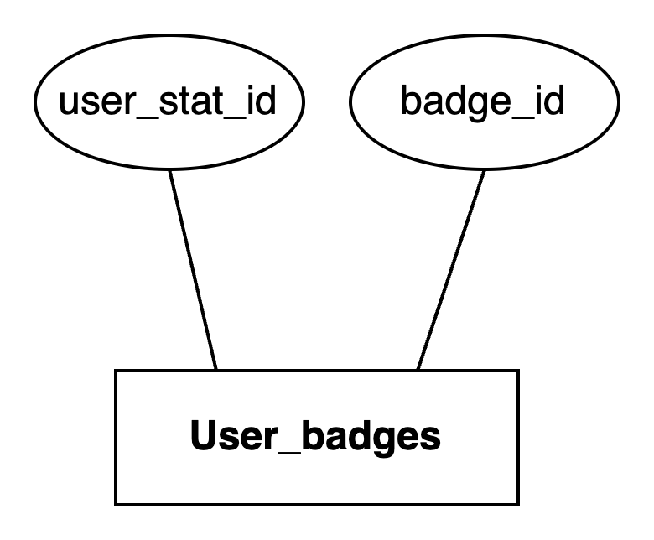

* + 1. ***Follow-User Entity***

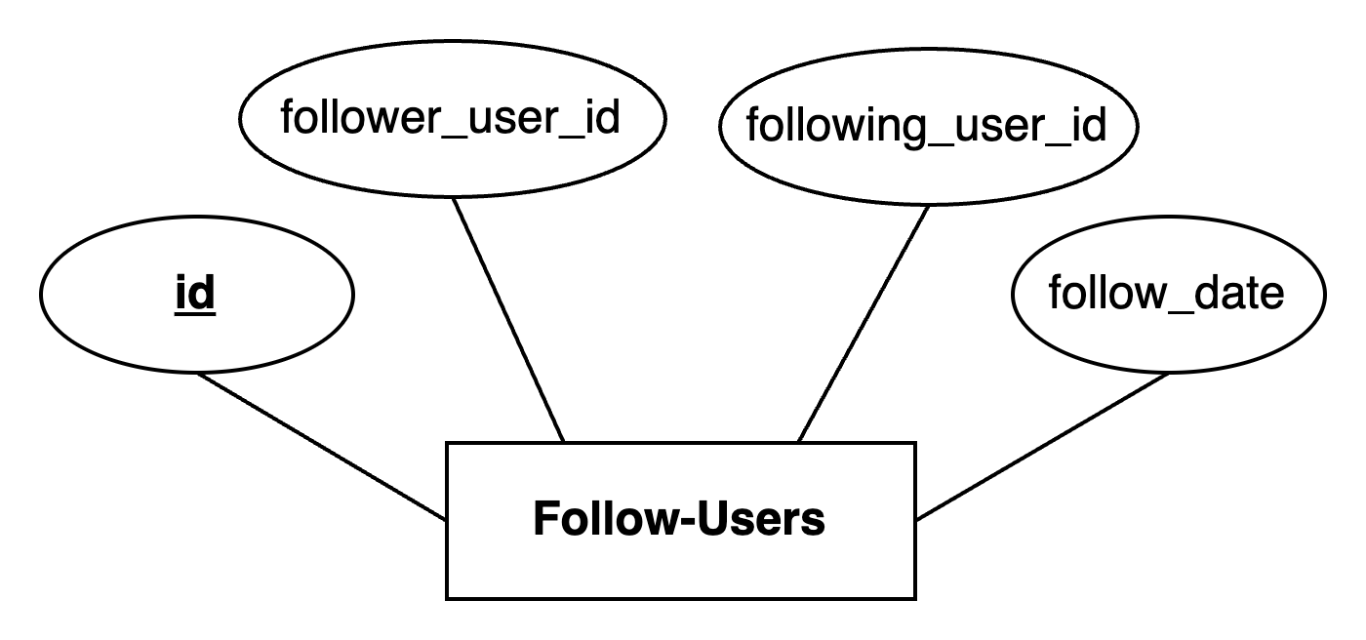

* + 1. ***FollowComment entity***

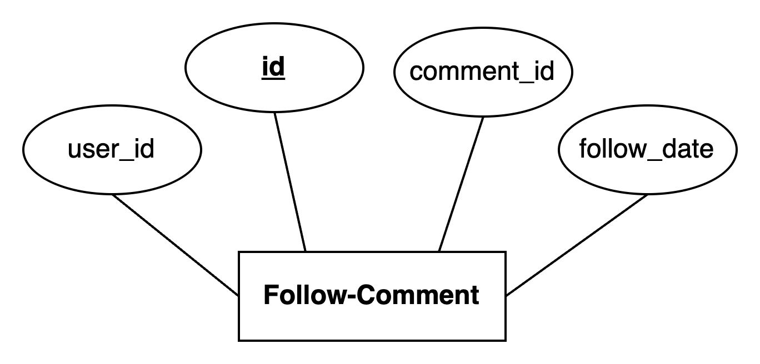

## Class Diagram

## Database Structure

### User Entity

In a forum system, the "User" entity represents the registered users who interact with the platform. Below are common attributes that you might include for the User entity:

| **Table: Users** | | | |
| --- | --- | --- | --- |
| **No** | **Attributes** | **Type** | **Description** |
|  | id | bigint | Primary Key: Unique identifier for each user. |
|  | username | varchar(50) | The username chosen by the user for identification purposes. |
|  | email | varchar(50) | The email address associated with the user's account, used for communication and account recovery. |
|  | password | varchar(100) | The hashed password used for authentication. It's important to store passwords securely, usually by hashing them before storing them in the database. |
|  | email_verified | bit(1) | "email_verified" is a boolean attribute that indicates whether a user's email address has been verified within a system or application. |
|  | account_status | enum(active, inactive, locked) | Represents the status of the user account (e.g., active, inactive, locked). |
|  | name | varchar(200) | The full name of the user. |
|  | provider_name | enum(google,github, local) | The name of the service provider or platform through which a user has authenticated or accessed a particular application or system. |
|  | provider_id | varchar(255) | The unique identifier is associated with a specific service provider or platform within a system. |
|  | full_name | varchar(50) | The full name of the user. |
|  | image_url | varchar(100) | The URL of the user's avatar or profile picture. |
|  | user_stat_id | bigint | Foreign Key referencing User_Stats entity |
|  | person_id | bigint | Foreign Key referencing Persons entity |
|  | created_at | datetime | Timestamp indicating when the user registered on the forum. |
|  | created_by | varchar(50) | The username is responsible for creating a particular record or entity within a table. |
|  | updated_at | datetime | The date and time when the account was updated. |
|  | updated_by | varchar(50) | The username is responsible for updating a particular record or entity within a table. |

### *Person* Entity

The person represents the other attributes associated with a User entity. In a general sense, a Person entity typically includes the following properties:

| **Table: Persons** | | | |
| --- | --- | --- | --- |
| **No** | **Attributes** | **Data Type** | **Description** |
|  | id | bigint | Primary Key: Unique identifier for each person. |
|  | address | varchar(255) | The address of the user. |
|  | bio | varchar(255) | A brief biography or description provided by the user to introduce themselves. |
|  | birth_date | date | The date of birth of the person. |
|  | gender | enum(male, female, other) | The gender of the person. |
|  | phone | varchar(50) | The phone number associated with the user's account, used for communication and account recovery. |
|  | profile_banner | tinyblob | The image for the top banner of the profile. |
|  | created_at | datetime | Timestamp indicating when the user registered on the forum. |
|  | created_by | varchar(50) | The username is responsible for creating a particular record or entity within a table. |
|  | updated_at | datetime | The date and time when the account was updated. |
|  | updated_by | varchar(50) | The username is responsible for updating a particular record or entity within a table. |

## 

### *Roles* Entity

The "Role" entity represents the different roles or levels of access that users can have within the forum system. Below are common attributes that you might include for the Role entity:

| **Entity: Roles** | | | |
| --- | --- | --- | --- |
| **No** | **Attributes** | **Data Type** | **Description** |
|  | id | bigint | Primary Key: Unique identifier for each role. |
|  | name | enum | The name or title of the role (e.g., Admin, Moderator, User). |

## 

**Relationship**: Each user can be assigned one or more roles, establishing a many-to-many relationship between Users and Roles. This relationship can be represented by an intermediary table.

| **Intermediary Table: User_roles** | | | |
| --- | --- | --- | --- |
| **No** | **Attributes** | **Data Type** | **Description** |
|  | user_id | bigint | Foreign Key referencing Users: The ID of the user assigned the role. |
|  | role_id | bigint | Foreign Key referencing Roles: The ID of the role assigned to the user. |
| Note: Composite Primary Key on (user_id, role_id). | | | |

### RefreshToken *Entity*

This entity represents the refresh tokens issued to users alongside access tokens. Refresh tokens are used to obtain new access tokens once the old ones expire without requiring the user to log in again.

| **Table: RefreshToken** | | | |
| --- | --- | --- | --- |
| **No** | **Attributes** | **Data Type** | **Description** |
|  | id | bigint | Primary Key: Unique identifier for each refresh token. |
|  | token | varchar(100) | The actual JWT refresh token string. |
|  | expiration_date | datetime | Timestamp indicating when the refresh token expires |
|  | user_id | bigint | Foreign Key referencing Users: The ID of the user assigned the token. |
|  | available | tinyint(1) | Represents the status of the token (active-1, revoked-0) |

## 

## 

### *User_stats* Entity

The "User Stat" entity stores and manages statistical information related to user activity, engagement, and behavior within a system or application.

| **Table: User_stats** | | | |
| --- | --- | --- | --- |
| **No** | **Attributes** | **Data Type** | **Description** |
|  | id | bigint | Primary Key: Unique identifier for each refresh token. |
|  | comment_count | bigint | The count of the post comments of users. |
|  | discussion | bigint | The count of the thread discussions of users. |
|  | last_login | datetime | A timestamp indicating when the user is last logged in. |
|  | profile_viewed | bigint | The count of the other users viewed. |
|  | last_comment_info_id | bigint | Foreign Key referencing Last-Comment |
|  | reputation | bigint | A number that measures a user's reputation. |

### 

### Forum *Group* Entity

The "Forum group" entity plays a crucial role in structuring discussions, promoting content discovery, facilitating community engagement, and enabling effective content management within a forum system. It serves as a foundational component that enhances the usability, organization, and governance of the forum platform.

| **Entity: Forum Groups** | | | |
| --- | --- | --- | --- |
| **No** | **Attributes** | **Data Type** | **Description** |
|  | id | bigint | Primary Key: A unique identifier for each forum group. |
|  | title | varchar(100) | The name or title of the forum group, which succinctly describes its theme or topic. |
|  | icon | varchar(50) | The icon of the forum group. |
|  | color | varchar(50) | The color of the icon of the forum group. |
|  | sort_order | int | Specifies the position or order of the category relative to other categories. This attribute determines the sorting order of categories when displayed to users. |
|  | created_by | varchar(50) | The username of the user who creates the forum group. |
|  | created_at | datetime | The date and time when the forum group was created. |
|  | updated_by | varchar(50) | The username of the user who updates the forum group. |
|  | updated_at | datetime | The date and time when the forum group was updated. |

## 

## 

### Forum Entity

The "Forum" entity represents a platform or online space where users can engage in discussions, share information, ask questions, and interact with one another. Below are common attributes that you might include for the Forums entity:

| **Table: Forums** | | | |
| --- | --- | --- | --- |
| No | Attributes | Data Type | Description |
|  | **id** | bigint | Primary Key: Unique identifier for each forum. |
|  | active | bit(1) | The "active" field indicates whether this forum is currently active or inactive. |
|  | icon | varchar(30) | The icon of the forum. |
|  | color | varchar(30) | The color of the icon of the forum. |
|  | title | varchar(100) | The title of the forum. |
|  | description | varchar(200) | The content describes the forum. |
|  | sort_order | int | "sort_order" attribute to specify the order in which forum should be sorted or arranged within a list. |
|  | forum_group_id | bigint | Foreign Key referencing Forum_Groups entity: |
|  | forum_stats_id | bigint | Foreign Key referencing Forum_Stats entity: |
|  | created_by | varchar(50) | The username of the user who creates the forum. |
|  | created_at | datetime | The date and time when the forum was created. |
|  | updated_by | varchar(50) | The username of the user who updates the forum. |
|  | updated_at | datetime | The date and time when the forum was updated. |

### *Forum stats* Entity

The "Forum stats" entity could be designed to provide insights into the overall activity, engagement, and performance of a forum.

| **Table: Forum_stats** | | | |
| --- | --- | --- | --- |
| No | Attributes | Data Type | Description |
|  | **id** | bigint | Primary Key: Unique identifier for each forum-stats. |
|  | comment_count | bigint | The count of the post comments of users. |
|  | discussion_count | bigint | The count of the thread discussions of users. |
|  | last_comment_info_id | bigint | Foreign Key referencing Comment_Info entity: |
|  | created_by | varchar(50) | The username of the user who creates the forum-stat. |
|  | created_at | datetime | The date and time when the forum-stat was created. |
|  | updated_by | varchar(50) | The username of the user who updates the forum-stat. |
|  | updated_at | datetime | The date and time when the forum was updated. |

### *Discussions* E*ntity*

The "Discussions" entity represents individual discussions or topics within a forum system. Below are common attributes that you might include for the Discussion entity:

| **Table: Discussions** | | | |
| --- | --- | --- | --- |
| No | Attributes | Data Type | Description |
|  | **id** | bigint | Primary Key: Unique identifier for each discussion. |
|  | forum_id | bigint | Foreign Key referencing Forums. The ID of the forum to which the discussion belongs. |
|  | discusston_stat_id | bigint | Foreign Key referencing Discussion Stat Entity. |
|  | title | varchar(100) | The title or subject of the thread. |
|  | created_at | datetime | Timestamp indicating when the discussion was created. |
|  | created_by | varchar(50) | The username who created the discussion. |
|  | updated_at | datetime | Timestamp indicating when the discussion was last updated. |
|  | updated_by | varchar(50) | The username who updated the discussion. |
|  | sticky | bit(1) | Indicates whether the thread is pinned or sticky, making it appear at the top of the thread list within its category. |
|  | closed | bit(1) | The status allows the discussion to continue or not. |
|  | important | bit(1) | mark the discussion as "hot" or not |
| Note: | | | |

### *Discussion Stats* E*ntity*

A "Discussion Stats" entity could be used to track and present various statistical information related to discussions happening within a forum or any other platform facilitating discussions. Below are common attributes that you might include for the Discussion Stats entity:

| **Entity: Discussion-Stats** | | | |
| --- | --- | --- | --- |
| No | Attributes | Data Type | Description |
|  | **id** | bigint | Primary Key: Unique identifier for each discussion-stats. |
|  | attachment_count | bigint | The number of attached files in the discussion. |
|  | thumbnail_count | bigint | The number of thumbnail files in the discussion. |
|  | comment_count | bigint | The number of the comments in the discussion. |
|  | last_viewed | datetime | The timestamp for a thread would indicate the last time a user accessed or viewed the thread discussion. |
|  | view_count | bigint | Typically refers to the number of times a particular item (in the discussion). |
|  | created_at | datetime | Timestamp indicating when the discussion-stat was created. |
|  | created_by | varchar(50) | The username who created the discussion-stat. |
|  | updated_at | datetime | Timestamp indicating when the discussion-stat was last updated. |
|  | updated_by | varchar(50) | The username who updated the discussion-stat. |
| Note: | | | |

### *Comment*-info Entity

A "Comment-Infos" entity could be designed to provide insights into the last comment in the discussion. Below are common attributes that you might include for the Comment_Infos entity:

| **Entity: Comment-Infos** | | | |
| --- | --- | --- | --- |
| No | Attributes | Data Type | Description |
|  | **id** | bigint | Primary Key: Unique identifier for each comment-info. |
|  | comment_id | bigint | Foreign Key referencing Comment Entity. |
|  | commenter_name | varchar(255) | Represents the username of the person who made a comment. |
|  | title | varchar(255) | The title of the last comment. |
|  | content_abbr | varchar(255) | The comment content abbreviated. |
|  | comment_date | datetime | Representing the date of the comment. |
|  | created_at | datetime | Timestamp indicating when the comment-info was created. |
|  | created_by | varchar(50) | The username who created the comment-info. |
|  | updated_at | datetime | Timestamp indicating when the comment-info was last updated. |
|  | updated_by | varchar(50) | The username who updated the comment-info. |
| Note: | | | |

### *Comment* entity

The "Comment" entity represents individual contributions or messages within a thread discussed in a forum system. Below are common attributes that you might include for the Comment entity:

| **Table: Comments** | | | |
| --- | --- | --- | --- |
| No | Attributes | Data Type | Description |
|  | **id** | bigint | Primary Key: A unique identifier for each comment. |
|  | title | varchar(255) | The title of the comment. |
|  | content | longtext | the content of the comment. |
|  | hidden | bit(1) | status hidden or show of this comment. |
|  | ip_address | varchar(80) | to store the IP address of the user who created the comment. |
|  | comment_vote_id | datetime | Timestamp indicating when the post was created. |
|  | reply_to_id | datetime | Timestamp indicating when the post was last updated. |
|  | created_at | datetime | Timestamp indicating when the comment was created. |
|  | created_by | varchar(50) | The username who created the comment. |
|  | updated_at | datetime | Timestamp indicating when the comment was last updated. |
|  | updated_by | varchar(50) | The username who updated the comment. |
| Note: | | | |

## 

### *Comment*-votes entity

A "Comment Votes" entity could be used to track and manage the voting activity on comments within a forum or any other platform where user-generated content is present. Below are common attributes that you might include for the Comment-Votes entity:

| **Table: Comment_votes** | | | |
| --- | --- | --- | --- |
| No | Attributes | Data Type | Description |
|  | **id** | bigint | Primary Key: A unique identifier for each comment-vote. |
|  | vote_up_count | int | The total number of upvotes a given item (a comment) has received. |
|  | vote_down_count | int | The total number of downvotes a given item (a comment) has received. |
|  | created_at | datetime | Timestamp indicating when the comment-vote was created. |
|  | created_by | varchar(50) | The username who created the comment-vote. |
|  | updated_at | datetime | Timestamp indicating when the comment-vote was last updated. |
|  | updated_by | varchar(50) | The username who updated the comment-vote. |

## 

### *Votes* entity

A "Votes" entity represents the interaction where users can express their preference or feedback on various items, such as posts, comments, or other content within a platform. Below are common attributes that you might include for the Votes entity:

| **Table: Votes** | | | |
| --- | --- | --- | --- |
| No | Attributes | Data Type | Description |
|  | **id** | bigint | Primary Key: A unique identifier for each vote. |
|  | vote_value | smallint | The value of the vote (up: 1 or down: -1) |
|  | vote_name | varchar(50) | The user name of the person who voted. |
|  | created_at | datetime | Timestamp indicating when the vote was created. |
|  | created_by | varchar(50) | The username who created the vote. |
|  | updated_at | datetime | Timestamp indicating when the vote was last updated. |
|  | updated_by | varchar(50) | The username who updated the vote. |

| **Intermediary Table: comment_vote_id** | | | |
| --- | --- | --- | --- |
| No | Attributes | Data Type | Description |
|  | coment_vote_id | bigint | Foreign Key referencing Comment-Vote Entity: The ID of the comment-vote assigned the vote. |
|  | vote_id | bigint | Foreign Key referencing Vote Entity: The ID of the vote assigned to the comment-vote. |
| Note: Composite Primary Key on (comment_vote_id, vote_id). | | | |

### Tags *entity*

The "Tags" entity represents keywords or labels associated with posts in a forum system, allowing users to categorize or filter posts based on specific topics or themes. Below are common attributes that you might include for the Tags entity:

| **Table: Tags** | | | |
| --- | --- | --- | --- |
| No | Attributes | Data Type | Description |
|  | **id** | bigint | Primary Key: A unique identifier for each tag. |
|  | label | varchar(100) | The name or label of the tag, representing a specific topic, keyword, or theme. |
|  | icon | varchar(30) | The icon of the tag. |
|  | color | varchar(30) | The color of the tag’s icon. |
|  | sort_order | int | "sort_order" attribute to specify the order in which tags should be sorted or arranged within a list. |
|  | disabled | bit(1) | A "disabled" attribute that indicates whether a tag is disabled or inactive within an application. |
|  | created_at | datetime | Timestamp indicating when the tag was created. |
|  | created_by | varchar(50) | The username who created the tag |
|  | updated_at | datetime | Timestamp indicating when the tag was last updated. |
|  | updated_by | varchar(50) | The username who updated the tag. |

| **Intermediary Table: Discussion_tags** | | | |
| --- | --- | --- | --- |
| No | Attributes | Data Type | Description |
|  | discussion_id | bigint | Foreign Key referencing Discussions Entity: The ID of the thread discussion assigned the tag. |
|  | tag_id | bigint | Foreign Key referencing Tags: The ID of the tag assigned to the tags. |
| Note: Composite Primary Key on (discussion_id, tag_id). | | | |

### File-Info *entity*

To support file uploads, specifically for images in your forum system, we create a new entity to manage these images.

| **Table: File-Info** | | | |
| --- | --- | --- | --- |
| No | Attributes | Data Type | Description |
|  | **id** | bigint | Primary Key: A unique identifier for each file. |
|  | name | varchar(200) | The name of the image file. |
|  | type | varchar(200) | The type of file. |
|  | url | varchar(200) | The path or URL to the stored file. |
|  | created_at | datetime | Timestamp indicating when the file was created. |
|  | created_by | varchar(50) | The username who created the file |
|  | updated_at | datetime | Timestamp indicating when the file was last updated. |
|  | updated_by | varchar(50) | The username who updated the file. |

| **Intermediary Table: Comment_attachment** | | | |
| --- | --- | --- | --- |
| No | Attributes | Data Type | Description |
|  | comment_id | bigint | Foreign Key referencing Comments Entity: The ID of the comment assigned the file. |
|  | file_info_id | bigint | Foreign Key referencing File-Info Entity |
| Note: Composite Primary Key on (comment_id, file_info_id). | | | |

| **Intermediary Table: Comment_thumnail** | | | |
| --- | --- | --- | --- |
| No | Attributes | Data Type | Description |
|  | comment_id | bigint | Foreign Key referencing Comments Entity: The ID of the comment assigned the file. |
|  | file_info_id | bigint | Foreign Key referencing File-Info Entity |
| Note: Composite Primary Key on (comment_id, file_info_id). | | | |

### *Badges* entity

In a forum system, badges are often awarded to users based on certain achievements, activities, or contributions. Below are common attributes that you might include for the Badges entity:

| **Entity: Badges** | | | |
| --- | --- | --- | --- |
| No | Attributes | Data Type | Description |
|  | **id** | bigint | Primary Key: A unique identifier for each badges. |
|  | name | varchar | The name or title of the badge, representing the achievement or activity for which it is awarded. |
|  | icon | varchar(100) | The icon/image associated with the badge is displayed to users when they earn the badge. |
|  | criteria | bigint | Based on the user's reputation(in user_stat table), determine the user's badge. |
|  | create_date | datetime | Timestamp indicating when the badge was created. |
| Note:   * Each badge can be awarded to multiple users. * Each user can earn multiple badges. * This relationship is a many-to-many relationship, as multiple users can earn the same badge, and a user can earn multiple badges. | | | |

| **Intermediary Table: User_badges** | | | |
| --- | --- | --- | --- |
| No | **Attributes** | Data Type | Description |
|  | user_stat_id | bigint | Foreign Key referencing User-Stat entity: Each user can earn multiple badges. |
|  | badge_id | bigint | Foreign Key referencing Badges: Each badge can be awarded to multiple users. |
| Note: Composite Primary Key on (user_stat_id, badge_id). | | | |

# 

### Follow-*User* entity

With this entity, you can track the relationships between users who follow each other within the platform. Each record in the "Follow-User" table represents a connection between a follower and the user they are following. The "FollowDate" attribute provides information about when the follow relationship was initiated, allowing for features such as sorting by newest followers or identifying recent activity within a user's follower network.

# 

| **Table: Follow-Users** | | | |
| --- | --- | --- | --- |
| No | Attributes | Data Type | Description |
|  | **id** | bigint | Primary Key: Unique identifier for the following relationship. |
|  | follower_user_id | bigint | Identifier of the user who is following another user (Foreign Key referencing User.UserID). |
|  | following_user_id | bigint | Identifier of the user who is being followed by another user (Foreign Key referencing User.UserID). |
|  | follow_date | datetime | Timestamp indicating when the following relationship was established. |

### *Bookmark* entity

With this entity, we can manage the relationships between users and the comments they are following. Each record in the "Bookmark" table represents a user following a specific comment.

| **Table: Follow-Comment** | | | |
| --- | --- | --- | --- |
| No | Attributes | Data Type | Description |
|  | **id** | bigint | Primary Key: Unique identifier for the follow-up relationship. |
|  | bookmark_by | varchar(50) | Username of the user who is following the comment. |
|  | comment_id | bigint | Foreign Key referencing Comment.id: Identifier of the comment being followed. |
|  | follow_date | datetime | Timestamp indicating when the following relationship was established. |
| 1. b | bookmarked | bit(1) | Status of bookmark |

# TASK SHEET REVIEW 2

| Project Ref. No.: | | Project Title: | Activity Plan Prepared By: | Date of Preparation of Activity Plan: | | | |
| --- | --- | --- | --- | --- | --- | --- | --- |
| No. | Task | Actual Start Date | Actual Days | Team Mate Names | Status |
| 1 | Architecture & Design of Project | TechForum | Vĩnh | 15/05/2024 | 01 | Vĩnh | Done |
| 2 | Use Case Diagram | 15/05/2024 | 01 | Hằng | Done |
| 3 | Sequence Diagram | 15/05/2024 | 01 | Hằng | Done |
| 4 | Data Flowchart Diagram (DFD) | 15/05/2024 | 01 | Huy, Hằng | Done |
| 5 | Flow Charts | 15/05/2024 | 01 | Hằng | Done |
| 6 | Class Diagram | 15/05/2024 | 01 | Vĩnh | Done |
| 7 | Entity-Relationship Diagram | 15/05/2024 | 01 | Huy, Hằng | Done |
| 8 | Database Structure | 15/05/2024 | 01 | Vĩnh | Done |

# 

# GUI Interface Design

# H1 (2/12)

## H2 (1.5/11)

* normal text (1.15/5)
* do not use > h2 (instead normal text)

style text with following(line space/ before para)